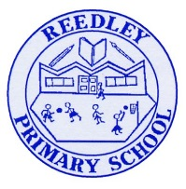
Year 4 Homework – The Sea Serpents and The Horendous Hydras

Date homework set: Thursday 11th March
To be returned to school by: Monday 15th March

Talking Topic
Talk to a family member or a friend about everything you have learned about The Alps

Tick when you have completed this task.

Maths
Practice your times tables on Time Tables Rockstars or ask for a paper copy.
https://play.ttrockstars.com/auth/school/student/

Log onto My Maths and complete the tasks I have set for you.
https://www.mymaths.co.uk/primary.html

Tick when you have completed this task.
Reading
WRITE THESE IN YOUR READING JOURNAL AND GET PARENTS TO SIGN
Read to an adult or an older sibling at least 3 times a week for 10-15 minutes. Get your reading record signed. We will be checking.

Complete your reading for pleasure.

Tick when you have completed this task.

Spellings
Practice the spelling of these 5 words using the methods we have learnt in No Nonsense Spelling.
Continue, forwards, early, heart, ordinary.
Write a sentence including each of these words, making sure they make sense.
Tick when you have completed this task.

Writing
Write 3 Kennings poems using what you have learnt in English throughout Lockdown

Tick when you have completed this task.
Theme
What would you need to take with you if you were going on holiday outside to The Alps
What else would you take?
Tick when you have completed this task.

