Year 5 Homework

Date homework set: 12.01.23
To be returned to school by: 17.01.23
Talking Topic (10 minutes)
- To discuss the following topic:
- “What is Science Fiction?”
Tick when you have completed this task.
Maths (10 minutes)
Complete the following:

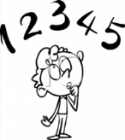
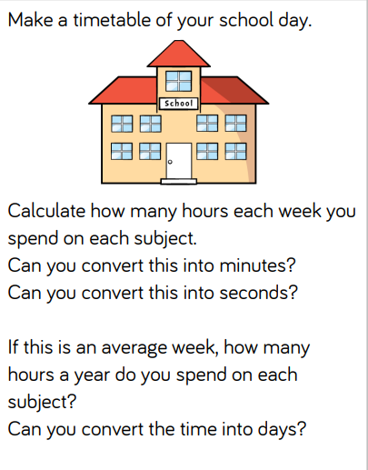

Tick when you have completed these tasks.
Writing (10 minutes)
Imagine an alien came to school. Write a description of it.

Spellings:
Learn these spellings and include them in your description.
Language
Identity
Immediate
Existence
Curiosity

Tick when you have completed this task.

