Year 2 Homework

Date homework set: Thursday 20th May 2021
To be returned to school by: Monday 24th May 2021

Talking Topic
Please complete your next book mark and discuss each of the parts of the book mark with your child. Your Child will have the next book mark stuck in their homework book.
Maths
- Check you know the 2,5,10 multiplication and division facts in any order.
- Complete the My Maths activity

Tick when you have completed these tasks.
https://www.mymaths.co.uk/

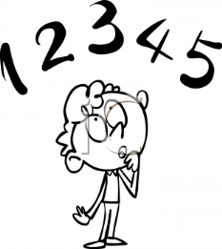
Bug Club
www.activelearnprimary.co.uk
- Log in and enjoy a book. Complete the activities as you read to win coins. You can use the coins to play games and do activities. You can re-read the book as often as you like.
- Try to read two books very week.

Spelling Shed
https://www.edshed.com/en-gb/login

• Log on and complete the activity
Purple Mash
https://www.purplemash.com/sch/reedleypri

- Log on and complete the activity
Writing
Key Skill: Use the suffixes ‘ment’ and ‘ness’ in a sentence.
E.g: The darkness swirled around me. Toads imprisonment for was 20 years.

