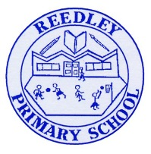
Year 4 Homework – The Sea Serpents and The Horendous Hydras

Date homework set: Thursday 13th May 2021
To be returned to school by: Monday 17th May 2021

Talking Topic
Talk to a member of your family or a friend about your favourite day of the week. Tell them why it is your favourite day.

Tick when you have completed this task.
Maths
Practice your times tables on Time Tables Rockstars or ask for a paper copy.
https://play.ttrockstars.com/auth/school/student/

Log onto My Maths and complete the tasks I have set for you.
https://www.mymaths.co.uk/primary.html

Tick when you have completed this task.
Reading
WRITE THESE IN YOUR READING JOURNAL AND GET PARENTS TO SIGN
Read to an adult or an older sibling at least 3 times a week for 10-15 minutes. Get your reading record signed. We will be checking.

Complete your reading for pleasure.

Tick when you have completed this task.

Spellings
Practice the spelling of these 5 words using the methods we have learnt in No Nonsense Spelling.
Popular, February, continue, describe, occasion
Write a sentence including each of these words, making sure they make sense.
Tick when you have completed this task.

Writing
Sort the words below into 2 lists; pronouns and not pronouns.

He, boy, we , hat, cute, ice-cream, ourselves, they, him will her, staff, sit, for I, us, to, you, yes, it, she, them, why, say, herself.

Tick when you have completed this task.
Theme
Research how sounds are made and the different types of sound.
Tick when you have completed this task.

