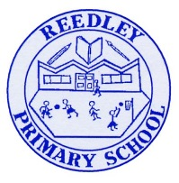
Year 4 Homework – The Sea Serpents and The Horrendous Hydras

Date homework set: Thursday 27.05.21
To be returned to school by: Tuesday 08.06.21

Talking Topic
Talk to a family member or a friend about your new Knowledge organiser. What are you excited to learn about next half term?
Tick when you have completed this task.
Maths
Practice your times tables on Time Tables Rockstars or ask for a paper copy.
https://play.ttrockstars.com/auth/school/student/

Log onto My Maths and complete the tasks I have set for you.
https://www.mymaths.co.uk/primary.html

Tick when you have completed this task.
Reading
WRITE THESE IN YOUR READING JOURNAL AND GET PARENTS TO SIGN
Read to an adult or an older sibling at least 3 times a week for 10-15 minutes. Get your reading record signed. We will be checking.

Complete your reading for pleasure.

Tick when you have completed this task.

Spellings
Practice the spelling of these 5 words using the methods we have learnt in No Nonsense Spelling.
Mention, famous, bicycle, famous, medicine
Write a sentence including each of these words, making sure they make sense.
Tick when you have completed this task.

Writing
Write five pieces of speech remembering to use inverted commas and the correct punctuation.

Tick when you have completed this task.
Theme
Find out what a herbivore, omnivore and carnivore is and see if you can list some of each.
Tick when you have completed this task.

