Year 5 Homework

Date homework set: 02.03.23
To be returned to school by: 07.03.23
Talking Topic (10 minutes)
- To discuss the following topic:
- “What activities did you do on World Book Day?”
Tick when you have completed this task.
Maths (10 minutes)
Complete the following:
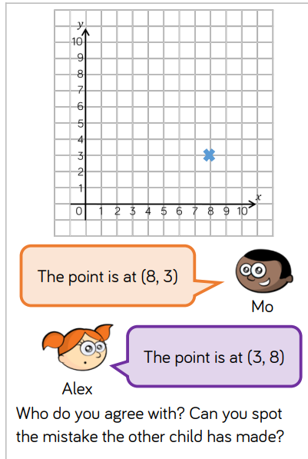

Tick when you have completed these tasks.
Writing (10 minutes)
Imagine a robot cam to visit school. Describe the robot.

Spellings:
Learn these spellings:
Queue
Temperature
Harass
Programme
Rhyme
Tick when you have completed this task.

