**Friday 10th March 2023**

**KL: To be able to identify and label basic parts of a tree.**

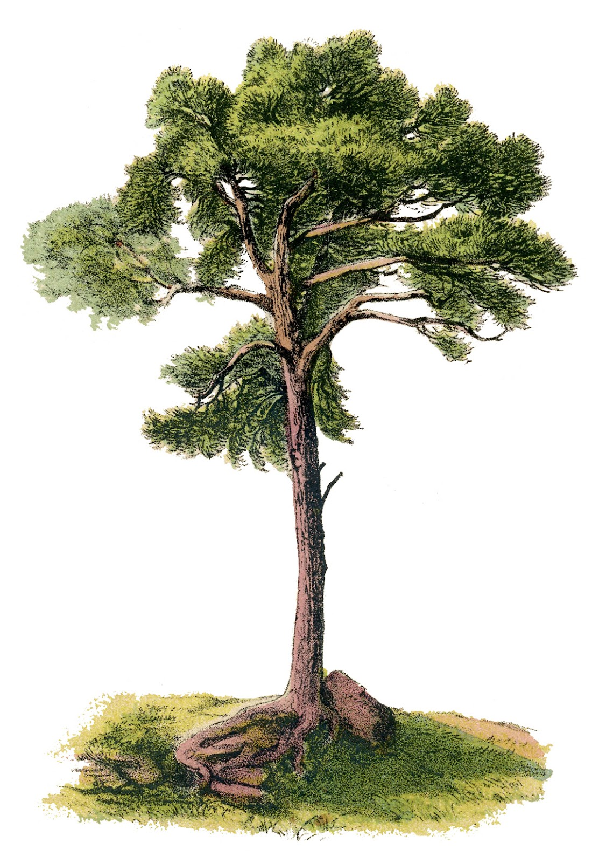

leaves

trunk

roots

branch

**Friday 10th March 2023**

**KL: To be able to identify and label basic parts of a tree.**



**CHALLENGE: Why are the roots important?**

**____________________________________________________________________________________________________________**

**______________________________________________________**