Vocabulary Dozen |  | Geography |  | Facts
Europe | Europe is a continent located entirely in the Northern Hemisphere and mostly in the Eastern Hemisphere. It is bordered by the Arctic Ocean to the north, the Atlantic Ocean to the west, Asia to the east, and the Mediterranean Sea to the south. | 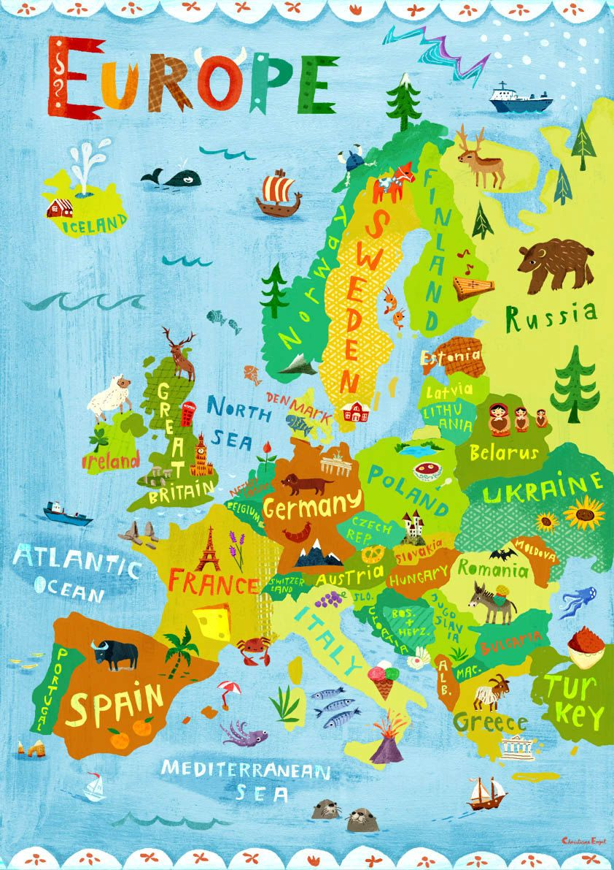 |  | - Population: about 740 million. That’s sounds a lot but there are five times that number of people living today in Asia!  - Land Area: 9,908,600 square kilometres (or 3,825,730 square miles) – it’s about a third of the size of Africa.  - Countries: 46 countries (of which 27 are members of the European Union or EU).  - Highest Peak: Mount Elbrus in Russia stands at 5,643 metres above sea level.  - Largest Lake: Lake Ladoga in north western Russia has an area of 17,700 square kilometres (6,800 square miles).  - Longest River: The Volga River in Russia is 3,530 kilometres (2,193 miles) long.  - Smallest Country (by land area and population): Vatican City is a tiny country within the Italian city of Rome. The Pope, the leader of the worldwide Catholic Church, lives here along with its 800 other citizens.  - Biggest Country (by land area): the Russian Federation is the biggest country by land area, not just in Europe but across the whole world!  - Languages: there are more than 200 different languages spoken in Europe. The EU recognises 23 languages that are in common use amongst its member countries, where two of every three Europeans live.
Continents | A continent is one of several very large landmasses.
Countries | A nation with its own government, occupying a particular territory.
Hemisphere | A half of the earth, usually as divided into northern and southern halves by the equator.
Region | An area, especially part of a country or the world having definable characteristics but not always fixed boundaries.
Longitude | Distance measure in degrees, east or West off an imaginary line that runs from the North-Pole to the South-Pole and passes through Greenwich.
Latitude | The distance north or south of the equator measured in degrees.
Human  Geography | Human Geography is the study of human interaction with the environment.
Physical Geography | Physical Geography examines the nature and environment and with it, natural hazards and their effects.
Design Technology
Think:  - Product - what could we make?  - Purpose - what is it for?  - User - who is going to use it |  |  | A peek at what we are going to be making/doing this term.
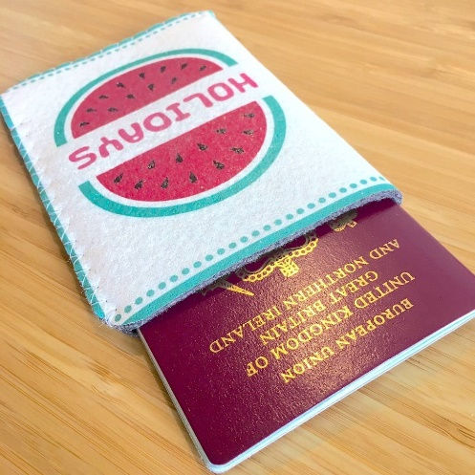
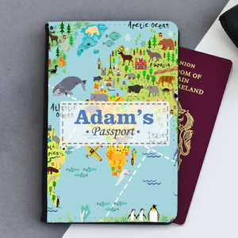

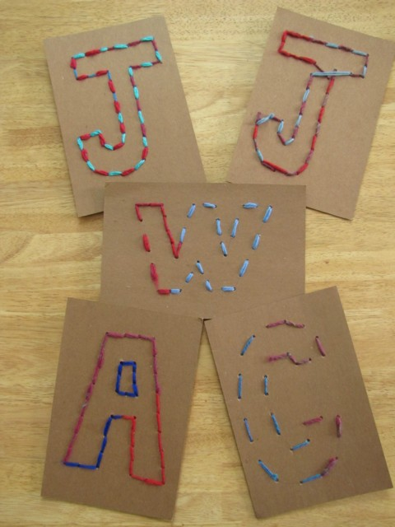
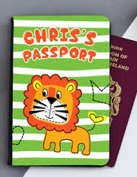

Passport | An official document issued by a government, certifying the holder's identity and citizenship and entitling them to travel under its protection to and from foreign countries.
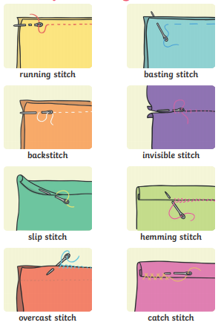
. Running stitch
. Overstitch
. Backstitch
. Blanket stitch

We will be learning to stitch next term
and listed above are some of the stiches
that we will use.

You will need to know how to tie a knot
during this topic so praticing over the
holdays with a piece of string would
be brilliant and means we will have more
time to make and decorate!

You will also be learning how to thread
A needle which can be very tricky!

