Vocabulary Properties of materials |  | Geography and Design Technology  Where does our food come from and when is it grown? |  | All about the United Kingdom.
Material | A physical substance that things can be made from | Design Technology | Which two course meal would be best to make during Autumn? | Physical geography, | Including: climate zones, biomes and vegetation belts
Properties | Property in the scientific field refers to a state of matter. For example, the property of water is that it is a liquid. The property of water vapor is that it is a gas. The property of ice is that it is a solid. | Where does our food come from? | 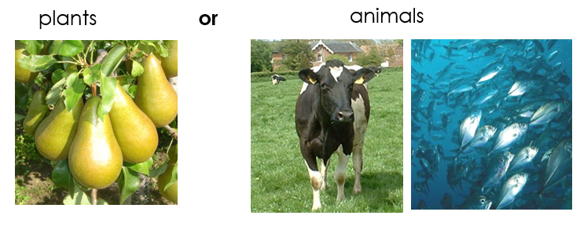 | Human geography | Including: land use, economic activity including trade links, and the distribution of natural resources including food and water.
Variables | Property in the scientific field refers to a state of matter. For example, the property of water is that it is a liquid. The property of water vapor is that it is a gas. The property of ice is that it is a solid. | Seasonality | Understand seasonality, and know where and how a variety of ingredients are grown, reared, caught and processed  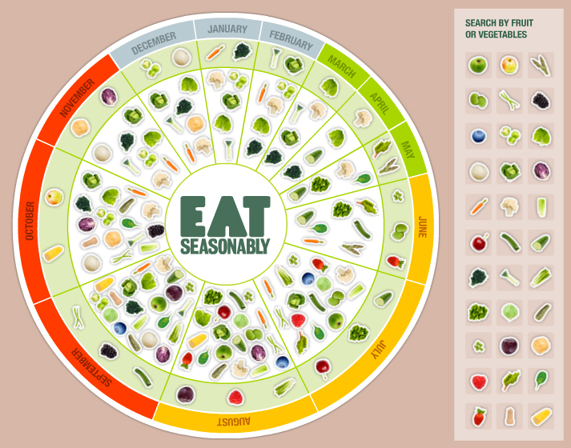 | Mapping | *Use a wide range of maps, atlases, globes and digital maps to locate countries and features studied.  *Relate different maps to each other and to aerial photos.  *Begin to understand the differences between maps e.g. Google maps vs Google Earth, and OS maps.  *Choose the most appropriate map/globe for a specific purpose.
Liquid | A substance that flows freely but can be measured by volume e.g. water or oil | What evaporation looks like.  Science  Art
Irreversible | Cannot be reversed back to its original state | 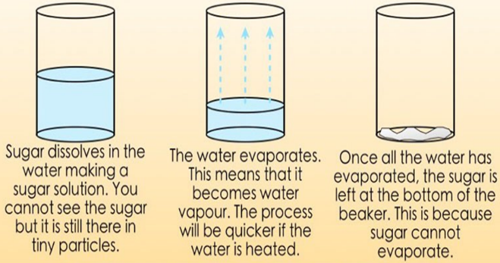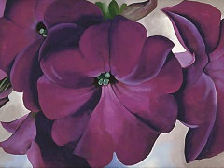  - Investigate using different drawing tools; grades of pencil, charcoal, chalk, graphite sticks, biros, pastels, oil pastels.  - Use dry media to make different marks, lines, patterns and shapes within a drawing.  - Children look at the work of still life painters such as Dutch masters, the Impressionists, Georgia O’Keefe.
Evaporation | The process of turning from liquid to vapour
Soluble | Able to be dissolved, especially in water.

