Year 5 Homework

Date homework set:7.9.19
To be returned to school by: 12.9.18

Talking Topic
- To discuss the following topic:
“Why I must learn my times tables?”
Tick when you have completed this task.
Maths
- Learn the 7 times table
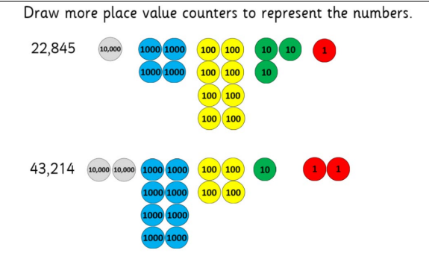
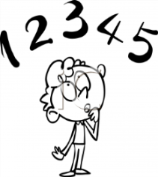
Tick when you have completed these tasks.
Reading
- Read the next chapter from your new reading for pleasure book.
- Complete three activities from your book- mark.
- Read your book on Bug Club and write the book in your reading diary.
Tick when you have completed this task.
Spag.
Complete the activity below.
Complete the SPAG activity, standard English, on SPAG.COM.
Writing
- Write a paragraph explaining why we should use neat handwriting.
Key Skill: Capital letters and full stops.
Tick when you have completed this task.

