Year 5 Homework
Date homework set: 11.10.23
To be returned to school by: 17.10.23
Talking Topic : To discuss the following topic:
“Why did we wear yellow on Tuesday?”
Tick when you have completed this task.
Maths : Complete the task below.
Draw a bar chart to show the data below.
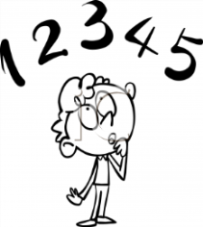
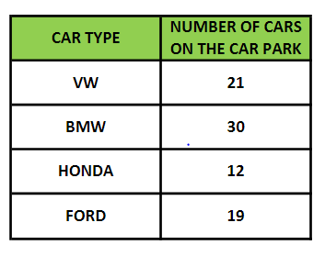
Reading : Read the next chapter from your new reading for pleasure book. *Ask someone to listen to you read.
*Complete your next bookmark.
Tick when you have completed this task.
Spelling : Learn this week’s spellings. Include them in a sentence.
bruise
forty
twelfth
foreign
harass
Spag. Complete the activity on SPAG. Com. Prefixes and suffixes. https://www.spag.com
Writing: Write a new story about the picture below.
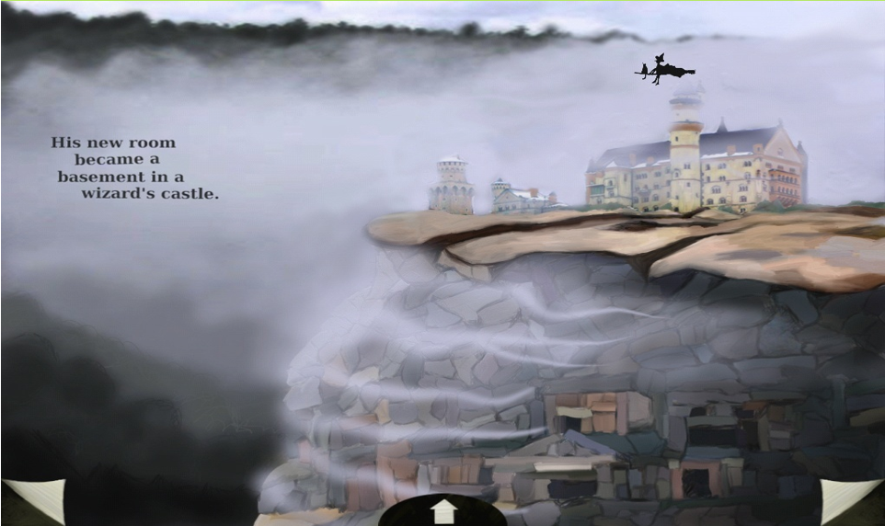
Reminder: If you would like extra homework there are more activities on:
Times Tables Rock Stars – Times Tables Rock Stars (ttrockstars.com)
ActiveLearn: Login (activelearnprimary.co.uk) (Bug club)
https://whizz.com/

