**Progression Toward Mental Calculation Strategies  
(Multiplication and Division)**

The ability to calculate mentally is an essential skill, but, as with written methods of calculation, children need to be taught. **It is important to ensure that when teaching particular strategies, children have the appropriate prerequisite skills and are guided as to how and when that strategy is appropriate.**

Children should be taught and encouraged to ask themselves the following questions when faced with a calculation:

* Do I know the answer?
* Can I work it out in my head?
* Do I need to do a jotting?
* Do I need to use a written method?

When using a jotting, there is no requirement to follow a particular method of recording.

A feature of mental calculation is that a type of calculation can often be worked out in several different ways. Which method is best will depend on the numbers involved, the age of the children and the range of methods that they are confident with.

In developing a progression through mental calculation strategies for multiplication and division, it is important that children understand the relevant concepts, in that multiplication is:

* repeated addition
* scaling

and division is:

* repeated subtraction (grouping)
* related to finding a fraction of a number (sharing)

They also need to understand and work with certain principles, that:

* multiplication and division are inverses
* multiplication is commutative (because it is based on addition which is also commutative) i.e. 3 x 5 = 5 x 3 but division is not i.e. 15 ÷3 ≠ 3 ÷ 15
* multiplication is associative i.e. 2 x (3 x 5) = (2 x 3) x 5 but division is not i.e. 30 ÷ (5 ÷ 2) ≠ (30 ÷ 5) ÷ 2
* commutativity and associativity mean that calculations can be rearranged to make them easier to calculate, e.g. (3 x 4) x 5 = 60 is the same as (5 x 4) x 3 = 60

PLEASE NOTE: To be mathematically accurate, 3 x 4 means 4 threes, or 3 + 3 + 3 + 3. Read correctly it means 3 multiplied four times. The first number in the calculation is the value which is being operated on by the second:

3 x 4

However, due to the fact that younger children often refer to the x sign as lots of, or groups of, the calculation is then commonly represented as 4 + 4 + 4. As multiplication is commutative, this is perfectly acceptable. It is a good idea to encourage children to think of any product either way round as this reduces the facts they need to remember by half. **yr**

**Early Learning Goal:**

***Children solve problems, including doubling.***

**Rapid Recall**

Children should be able to:

* Count in steps of one, forwards and backwards

In the EYFS, children are encouraged to develop a mental picture of the number system in their heads to use for calculation. They should experience practical calculation opportunities using a wide variety of practical equipment, including small world play, role play, counters, cubes etc.

**Solve problems involving doubling**

Children may investigate items such as Lego bricks, ice cube trays and baking tins, paint boxes etc, which can show doubles, e.g. one side of the Lego brick is four, so double four is eight.

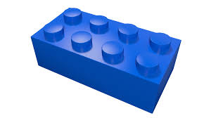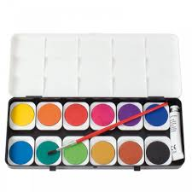

They may develop ways of recording calculations using pictures, etc.



A child’s jotting showing the fingers on each hand as a double.

A child’s jotting showing double three as three cookies on each plate.

**Solve problems involving halving and sharing**

Children may investigate sharing items or putting items into groups using items such as egg boxes, ice cube trays and baking tins which are arrays.

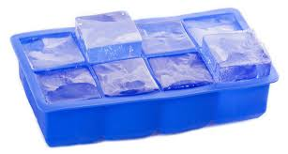

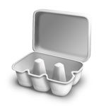

They may develop ways of recording calculations using pictures, etc.



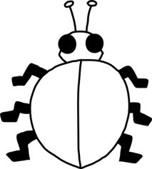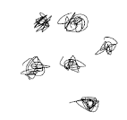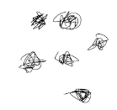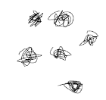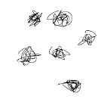

A child’s jotting showing how they shared the apples at snack time between two groups.

A child’s jotting showing halving six spots between two sides of a ladybird.

**Y1**

**End of Year Objective:**

***Solve one-step problems involving multiplication and division, by calculating the answer using concrete objects, pictorial representations and arrays with support.***

**Rapid Recall**

Children should be able to:

* Count in multiples of twos, fives and tens
* Recall and use doubles of all numbers to 10 and corresponding halves

**Solve one-step problems involving multiplication**

In Year One, children will continue to solve multiplication problems using practical equipment and jottings. They may use the equipment to make groups of objects. Children should see everyday versions of arrays, e.g. egg boxes, baking trays, ice cube trays, wrapping paper etc. and use this in their learning, answering questions such as 'How many eggs would we need to fill the egg box? How do you know?'

**Solve one-step problems involving division**

In Year One, children will continue to solve division problems using practical equipment and jottings. They should use the equipment to share objects **equally** and separate them into **equal** groups, answering questions such as 'If we share these six apples between the three of you, how many will you each have? How do you know?' or ‘If six football stickers are shared between two people, how many do they each get?’ They may solve both of these types of question by using a 'one for you, one for me' strategy until all of the objects have been given out.

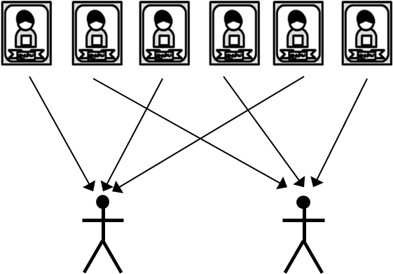

Children will also answer questions that involve grouping rather than sharing, such as ‘Pip puts two football stickers on each page of his sticker book. How many pages does he need?’ This type of problem requires the children to make equal groups from the whole amount.

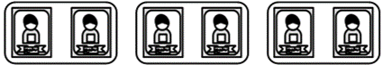**Y2**

**End of Year Objective:**

***Calculate mathematical statements for multiplication and division within the multiplication tables.***

**Rapid Recall**

Children should be able to:

* Count in steps of 2, 3 and 5 from 0
* Recall and use multiplication facts for the 2, 5 and 10 multiplication tables
* Derive and use doubles of simple two-digit numbers (numbers in which the ones total less than 10)
* Derive and use halves of simple two-digit even numbers (numbers in which the tens are even)
* Recognise odd and even numbers

**Mental Strategies**

Children should be able to represent a variety of multiplication and division calculations for facts not limited to two, five and ten times tables. The image and its link to the meaning of multiplication or divisionneeds to be securely understood. As children learn to recall more multiplication and division facts, they should make a choice about the calculations they need to represent to find the answer, and those they can recall.

**Calculate mathematical statements for multiplication**

***Repeated addition using practical equipment***

Children should initially show multiplication as repeated addition in a random arrangement, e.g. 5 x 3 can be shown as five groups of three with counters.

***Repeated addition using arrays***

Practical equipment can be used to represent 5 x 3 as an array in two forms (as it has commutativity).

5 + 5 + 5 = 15

3 + 3 + 3 + 3 + 3 = 15

***Repeated addition using jottings***

Children can develop their recordings of multiplication to using jottings.



***Repeated addition using a bead bar / bead string***

Children can use bead strings or bead bars to help them calculate mathematical statements for multiplication.

5 x 3 = 5 groups of 3

5 x 3 = 15

15

12

9

6

3

***Repeated addition using a number line***

Once children are familiar with the idea of repeated addition using a bead bar or bead string, they can begin to use a number line to show the counting steps.

5 x 3 = 5 groups of 3

5 x 3 = 15

+3

+3

+3

+3

+3

0 3 6 9 12 15

*Examples of calculations*

5 x 4 using commutativity to identify a recalled fact

3 x 10 recalled fact

7 x 3 using a representation

2 x 9 using knowledge that multiplying by 2 is doubling

6 x 6 using a representation

*Prerequisite skills:*

* Count forwards and backwards in ones
* Identifying equal groups

***Doubling using partitioning and base 10 equipment***

When deriving and using doubles of simple two-digit numbers where the ones total is less than 10, children should be taught to represent the number, and then repeat so they have two groups that are **equal in value**, developing their understanding that doubling is the same as multiplying by 2

e.g. double 24.



They should then put the tens together and the ones together:



Finally recombining the tens and ones to find the double, e.g. double 24 is 48.

***Doubling using partitioning and jottings***

Children can then develop their use of jottings to represent the number, e.g. double 24, representing the number twice:

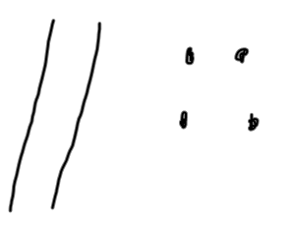 

Finally, they can count in tens, and then ones to recombine the number, e.g. 10, 20, 30, 40, 41, 42, 43, 44, 45, 46, 47, 48.

***Doubling using partitioning***

e.g. double 24

20

24

4

40

8

48

The diagram above illustrates the way children should be thinking about doubling using partitioning, but it is not necessary for them to record in this way if it is not helpful to the child.

*Examples of calculations*

Double 43

Double 31

*Prerequisite skills:*

* Count forwards and backwards in ones and tens
* Represent a number using base ten equipment
* Partition a two digit number into tens and ones
* Recombine a multiple of ten and a multiple of one

**Calculate mathematical statements for division**

***Repeated subtraction using practical equipment***

Children should initially show division as repeated subtraction in a random arrangement, e.g. 15 ÷ 3 can be shown as fifteen divided into groups of three with counters.

15 ÷ 3 = 5 **groups**

***Repeated subtraction using arrays***

Arrays can be used to help children to identify the groups of the divisor in a division calculation, e.g. the groups of 3 in the calculation 15 ÷ 3.

15 ÷ 3 = 5 **groups**

***Repeated subtraction using jottings***

Children can develop their recordings of division to using jottings, e.g. 15 ÷ 3,



***Repeated subtraction using bead bar / bead string***

Children can use bead strings or bead bars to help them calculate mathematical statements for division.

15 ÷ 3 = 5 **groups**

15

12

9

6

3

***Repeated subtraction using number line***

Once children are familiar with the idea of repeated subtraction using a bead bar or bead string, they can begin to use a number line to show the counting steps.

15 ÷ 3 = 5 **groups**

-3

-3

-3

-3

-3

0 3 6 9 12 15

*Examples of calculations*

20 ÷ 5 recalled fact

40 ÷ 10 recalled fact

18 ÷ 3 using a representation

12 ÷ 2 using knowledge that dividing by 2 is halving

*Prerequisite skills:*

* Count forwards and backwards in ones
* Identifying equal groups

***Halving using partitioning and base 10 equipment***When deriving and using halves of simple two-digit even numbers where the tens are even, children should first represent the number, e.g. Find half of 48



They should halve the tens and then halve the ones by sharing each of them into two equal groups, developing their understanding that halving is the same as dividing by 2. A diagram such as the one below might be useful:



Finally, they identify what half of the whole number is, e.g. Half of 48 is 24

***Halving using partitioning and jottings***

Children can then develop their use of jottings to represent the number, e.g. Find half of 48

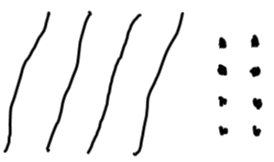

They then share each element of the number into two equal groups. A diagram such as the one below might be useful:

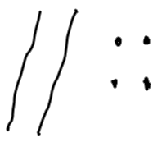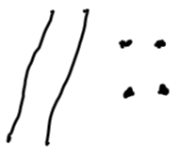

Finally, they identify what half of the whole number is, e.g. Half of 48 is 24.

***Halving using partitioning***

e.g. Find half of 48

40

48

8

20

4

24

The diagram above illustrates the way children should be thinking about halving using partitioning, but it is not necessary for them to record in this way if it is not helpful to the child.

*Examples of calculations*

Find half of 64

Find half of 28

*Prerequisite skills:*

* Count forwards and backwards in ones and tens
* Represent a number using base ten equipment
* Partition a two-digit number into tens and ones
* Recombine a multiple of ten and a multiple of ones

**Y3**

**End of Year Objective:**

***Write and calculate mathematical statements for multiplication and division using the multiplication tables that they know, including two-digit numbers times one-digit numbers.***

**Rapid Recall**

Children should be able to:

* Count in multiples of 4, 8, 50 and 100
* Recall and use multiplication and division facts for the 3, 4 and 8 multiplication tables
* Derive and use doubles of all numbers to 100 and corresponding halves
* Derive and use doubles of all multiples of 50 to 500

**Mental Strategies**

Children should be able to represent multiplication and division calculations, including two-digit numbers multiplied by one-digit numbers. As children learn to recall more multiplication and division facts, they should make a choice about the calculations they need to represent to find the answer, and those they can recall.

**Calculate mathematical statements for multiplication**

***Multiply a one- or two-digit number by 10 and a one-digit number by 100 using base 10 equipment***

Children should initially represent the calculation using base 10 equipment, e.g. 23 x 10

***1010***

***1***

***1***

***1***

All of the base 10 pieces need to be made ten times greater.

***101010***



The children should then compare the two numbers in place value columns.

H T U

2 3

2 3 0

They should notice that each digit has moved one place to the left, i.e. become ten times greater.

***Multiply a one- or two-digit number by 10 and a one-digit number by 100 using a place value chart***

Building on their knowledge from using the base 10 equipment, children can use transparent counters to help them develop their understanding of multiplying by 10 and 100,

e.g. 46 x 10

The children represent 46 on a place value chart using transparent counters.

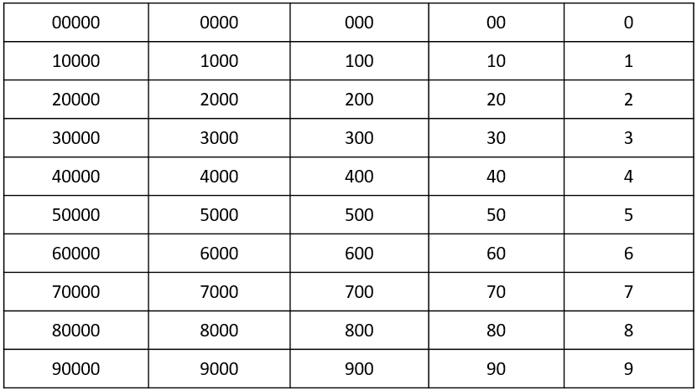

They then move each counter one place to the left to multiply the number by 10.



They then recombine this number to create 460.

*Examples of calculations*

3 x 10

7 x 100

62 x 10

*Prerequisite skills:*

* Represent numbers up to three digits using base 10 equipment
* Partition a two digit number into tens and ones
* Recombine multiples of hundreds and tens

***Within known tables, use related facts to multiply T0 by a one-digit number***

*NB T0 represents a two digit multiple of ten*

Children should be encouraged to identify the **relationships** between numbers in multiplication calculations, e.g. 7 x 8 = 56 could be represented using a multiplication trio as this model allows children to see the **relationships** between the numbers:

56

7

8

This can be used to derive the following calculations:

7 x 8 = 56

8 x 7 = 56

Children can then use the multiplication trio to derive related facts, e.g. 70 x 8 =

560

70

8

Children should be able to explain that because 70 is ten times greater than 7, the answer to 70 x 8 will be ten times greater than 56. They can then use their understanding of multiplying by 10 to calculate this.

*Examples of calculations*

60 x 3

50 x 4

30 x 8

*Prerequisite skills:*

* Recall 2, 3, 4, 5, 8 and 10 multiplication tables
* Understand the effect of multiplying a one- or two-digit number by 10

***Within known tables, use partitioning to multiply T1 by a one-digit number***

*NB T1 represents a two digit number with one as the units*

Squared paper can be used to develop children’s understanding of this calculation and how it is related to multiplying T0 by a one-digit number.

e.g. 31 x 4

Children make the calculation 30 x 4 using squared paper.

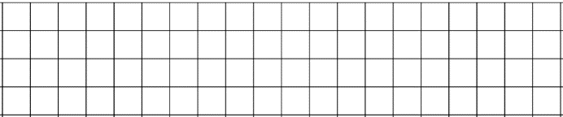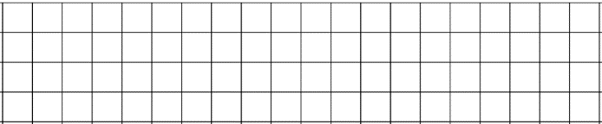

4

30

They should be able to calculate, by using related facts, that 30 x 4 = 120. The children should now consider how to change the representation of 30 x 4 into 31 x 4, i.e. by adding one extra column of four:



4

31

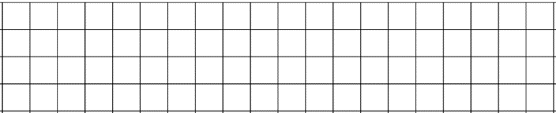

So 31 x 4 = 30 x 4 add 1 x 4

31 x 4 = 120 + 4

31 x 4 = 124

*Examples of calculations*

51 x 3

61 x 4

31 x 8

*Prerequisite skills:*

* Recall 2, 3, 4, 5, 8 and 10 multiplication tables
* Create an array to represent a multiplication calculation
* Understand the effect of multiplying a one- or two-digit number by 10
* Use related facts to multiply T0 by a one-digit number within known tables

***Use compensation to multiply 19 by a one-digit number***

Squared paper can be used to develop children’s understanding of this calculation and how it is related to multiplying twenty by a one-digit number.

e.g. 19 x 4

Children make the calculation 20 x 4 using squared paper.

4

20

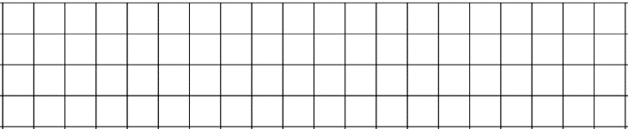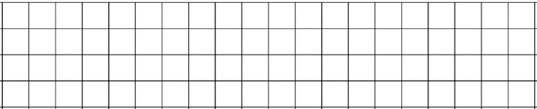

They should be able to calculate, by using related facts, that 20 x 4 = 80. The children should now consider how to change the representation of 20 x 4 into 19 x 4, i.e. by subtracting one column of four:



4

19

So 19 x 4 = 20 x 4 subtract 1 x 4

19 x 4 = 80 – 4

19 x 4 = 76

*Examples of calculations*

19 x 3

19 x 5

19 x 8

*Prerequisite skills:*

* Recall 2, 3, 4, 5, 8 and 10 multiplication tables
* Create an array to represent a multiplication calculation
* Understand the effect of multiplying a one- or two-digit number by 10
* Use related facts to multiply 20 by a one-digit number within known tables

***Use partitioning to double any two-digit number***

Children should continue to develop their understanding of doubling from Y2. They should use related facts to double two-digit multiples of 10. For example, double 7 is 14 so double 70 (ten times greater than 7) is 140 (ten times greater than 14).

e.g. double 76

76

6

70

1400

12

152

The diagram above illustrates the way children should be thinking about doubling using partitioning, but it is not necessary for them to record in this way if it is not helpful to the child.

*Examples of calculations*

Double 39

Double 52

Double 85

*Prerequisite skills:*

* Count forwards in ones and tens, crossing tens and hundreds boundaries
* Partition a two-digit number into tens and ones
* Use related facts to double a two-digit multiple of 10
* Recombine a multiple of ten and a multiple of one

***Use related facts or partitioning to double any multiple of 50 to 500***

Children should use related facts to double multiples of 100. For example, double 3 is 6 so double 300 is 600.

e.g. double 350

350

50

300

100

600

700

*Examples of calculations*

Double 250

Double 450

Double 150

*Prerequisite skills:*

* Count forwards in tens and hundreds
* Partition a multiple of 50 into hundreds and tens
* Use related facts to double a multiple of 100 which is less than 500

**Calculate mathematical statements for division**

Children in Year 3 are learning division by chunking at this point, so calculations should fit the method being taught.

***Use related facts to divide T0 by a one-digit number***

*NB T0 represents a multiple of ten*

Children should be encouraged to identify the **relationships** between numbers in division calculations, e.g. 8 ÷ 4 = 2 could be represented using a division trio as this model allows children to see the **relationships** between the numbers:

8

2

4

This can be used to derive the following calculations:

8 ÷ 4 = 2

8 ÷ 2 = 4

Children can then use the division trio to derive related facts, e.g. 80 ÷ 4 =

80

4

20

Children should be able to explain that because 80 is ten times greater than 8, the answer to 80 ÷ 4 will be ten times greater than 2.

*Examples of calculations*

60 ÷ 3

80 ÷ 2

90 ÷ 3

*Prerequisite skills:*

* Recall 2, 3 and 4 multiplication tables
* Understand the effect of multiplying a one-digit number by 10

***Use partitioning to halve even numbers up to 200***Where the tens digit is even, children can use related facts to halve the multiple of 10. For example, half of 14 is 7 so half of 140 (ten times greater than 14) is 70 (ten times greater than 7).

e.g. Find half of 146

146

140

6

70

3

73

Where the tens digit is odd, children can use partitioning in different ways to help them to calculate, recognising that partitioning the number into an even number of tens and the remainder will help them calculate more efficiently.

e.g. Find half of 78

78

18

60

30

9

39

The diagram above illustrates the way children should be thinking about halving using partitioning, but it is not necessary for them to record in this way if it is not helpful to the child.

*Examples of calculations*

Find half of 162 by partitioning into 160 and 2

Find half of 94 by partitioning into 80 and 14

Find half of 136 by partitioning into 120 and 16

*Prerequisite skills:*

* Partition a two-digit and three-digit number in different ways
* Use related facts to half a multiple of 10, where the tens digit is even, up to 200
* Recombine a multiple of ten and a multiple of one

**Y4**

**End of Year Objective:**

***Use place value, known and derived facts to multiply and divide mentally, including:***

***- multiplying by 0 and 1***

***- dividing by 1***

***- multiplying together three numbers***

**Rapid Recall**

Children should be able to:

* Count in multiples of 6, 7, 9, 25 and 1000
* Recall multiplication and division facts for multiplication tables up to 12 x 12
* Use partitioning to double or halve any number, including decimals to one decimal place
* Recognise and use factor pairs

**Mental Strategies**

Children should be able to represent multiplication and division calculations, including two-digit multiplied by one-digit numbers. As children learn to recall more multiplication and division facts, they should make a choice about the calculations they need to represent to find the answer, and those they can recall.

**Use place value, known and derived facts to multiply mentally**

***Multiply a one- or two-digit number by 10 and 100***

Building on their understanding from Year 3, children use place value columns to multiply one or two-digit numbers by 10 and 100.

e.g. 42 x 100 =

Th H T U

4 2

4 2 0 0

*Examples of calculations*

7 x 10

9 x 100

71 x 10

63 x 100

*Prerequisite skills:*

* Understand and use place value columns when representing numbers
* Understand the effect of multiplying a number by 10 or 100

***Use related facts to multiply H00 by a one-digit number***

*NB H00 represents a multiple of 100*

Children should be encouraged to identify the **relationships** between numbers in multiplication calculations, e.g. 7 x 9 = 63 could be represented using a multiplication trio as this model allows children to see the **relationships** between the numbers:

63

7

9

This can be used to derive the following calculations:

7 x 9 = 63

9 x 7 = 63

Children can then use the multiplication trio to derive related facts, e.g. 700 x 9 =

6300

700

9

Children should be able to explain that because 700 is one hundred times greater than 7, the answer to 700 x 9 will be one hundred times greater than 63. They can then use their understanding of multiplying by 100 to calculate this.

***Use factor pairs to multiply H00 by a one-digit number***

Calculations that involve multiplying H00 by a one-digit numbercan be broken down into smaller steps by using factor pairs.

e.g. 700 x 9 =

becomes 7 x 100 x 9 = (using knowledge of factor pairs)

which becomes 7 x 9 x 100 = (using knowledge of commutativity/associativity)

which becomes 63 x 100 = 6300

*Examples of calculations*

600 x 7

500 x 8

900 x 6

*Prerequisite skills:*

* Recall multiplication tables
* Understand the effect of multiplying a one- or two-digit number by 100
* Recognise and use factor pairs

***Use compensation to multiply T9 by a one-digit number***

*NB T9 represents a two-digit number with 9 ones*

Building on their understanding from Year 3 of multiplying 19 by a one-digit number using squared paper, children multiply by the nearest multiple of ten and then compensate appropriately.

e.g. 59 x 4 =

59 x 4 = 60 x 4 subtract 1 x 4

60 x 4 = 240

So 59 x 4 = 240 – 4 (one group of 4 less than 240)

59 x 4 = 236

*Examples of calculations*

49 x 3

29 x 7

89 x 6

*Prerequisite skills:*

* Recall multiplication tables
* To understand how multiplying by 9 is related to multiplying by 10
* Use related facts to multiply T0 by a one-digit number

***Use related facts to multiply TU x 5 (by multiplying by 10 and halving)***

When learning multiplication tables, children should be encouraged to identify related facts.

e.g. 8 x 10 = 80

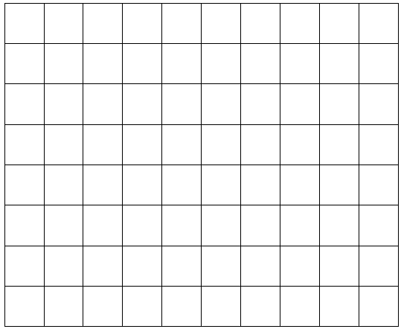

This can be used to calculate:

8 x 5 = 40 (half of 8 x10) because 5 is half of 10

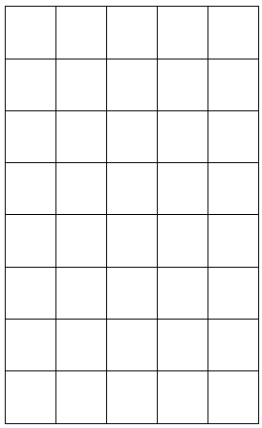

This strategy can then be applied to calculating TU x 5.

e.g. 46 x 5 =

46 x 10 = 460

so

46 x 5 = 230

*Examples of calculations*

28 x 5

81 x 5

54 x 5

*Prerequisite skills:*

* Recall multiplication tables
* Understand the relationship between multiplying by 10 and multiplying by 5
* Multiply a two-digit number by 10
* Halve multiples of 10 up to three-digits

***Use related facts to multiply TU x 20 (by multiplying by 10 and doubling)***

When learning multiplication tables, children should be encouraged to identify related facts.

e.g. 3 x 10 = 30

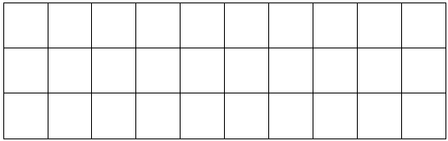

This can be used to calculate:

3 x 20 = 60 (double 3 x 10) because 20 is double 10

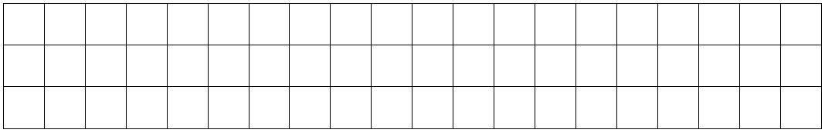

This strategy can then be applied to calculating TU x 20.

e.g. 46 x 20 =

46 x 10 = 460

so

46 x 20 = 920

*Examples of calculations*

34 x 20

47 x 20

68 x 20

*Prerequisite skills:*

* Recall multiplication tables
* Understand the relationship between multiplying by 10 and multiplying by 20
* Multiply a two-digit number by 10
* Double multiples of 10 up to three-digits

***Use partitioning to multiply TU by a one-digit number***

Building on their understanding of the grid method of multiplication from Year 3, children in Year 4 may choose to multiply TU x U using partitioning, but without the use of the grid.

e.g. 67 x 4 =

60 x 4 = 240

7 x 4 = 28

67 x 4 = 268

*Examples of calculations*

57 x 4

36 x 7

93 x 6

*Prerequisite skills:*

* Recall multiplication tables
* Partition a two-digit number into tens and ones
* Recombine a multiple of ten and a multiple of one

***Use partitioning to double numbers including those with one decimal place***

Children should use related facts to double numbers. For example, double 7 is 14 so double 0.7 (ten times smaller than 7) is 1.4 (ten times smaller than 14).

e.g. double 6.8

6.8

0.8

6

1.6

12

13.6

The diagram above illustrates the way children should be thinking about doubling using partitioning, but it is not necessary for them to record in this way if it is not helpful to the child.

*Examples of calculations*

Double 374

Double 4524

Double 7.6

*Prerequisite skills:*

* Count forwards in tenths, ones, tens, hundreds and thousands
* Partition a number into thousands, hundreds, tens, ones and tenths
* Use related facts to double multiples of tenths, ones, tens, hundreds and thousands
* Recombine multiples of tenths, ones, tens, hundreds and thousands

***Multiply together three numbers***

Children should be able to represent multiplying three numbers together practically, e.g. using counters

e.g. 2 x 3 x 4 could be represented as:



2 x 3 four times

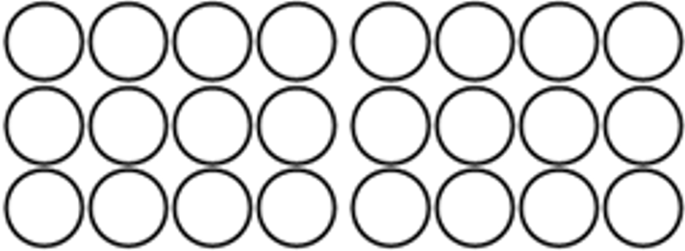

3 x 4 two times



2 x 4 three times

Once children understand how the calculation can be shown practically or pictorially, they should then be encouraged to choose an appropriate order for calculating based on the numbers involved.

e.g. 5 x 7 x 4 =

This could be calculated as:

5 x 7 x 4 = 5 x 4 x 7 = 4 x 7 x 5 =

28

20

35

35 x 4 = 140 20 x 7 = 140 28 x 5 = 140

Children may choose 5 x 4 x 7 as the easiest calculation because 5 x 4 results in a multiple of 10.

*Examples of calculations*

3 x 4 x 6

7 x 3 x 9

5 x 6 x 8

*Prerequisite skills:*

* Represent a multiplication using an array
* Understand that multiplication can be done in any order
* Recall multiplication tables
* Multiply a two-digit number by a one-digit number

***Multiply a number by 0 or 1***

Children should realise through investigation that a calculation is not needed when multiplying by 0 or 1

Any number multiplied by 0 will result in zero, e.g. 76 x 0 = 0 because any number of empty groups does not have a value.

Any number multiplied by 1 will result in the number itself, 356 x 1 = 356 because it is one group of the original amount.

**Use place value, known and derived facts to divide mentally**

***Divide a number by 10 and 100 using base 10 equipment***

Children should initially represent the calculation using base 10 equipment, e.g. 230 ÷ 10

***101010***



All of the base 10 pieces need to be made ten times smaller.

***1010***

***1***

***11***

The children should then compare the two numbers in place value columns.

H T U

2 3 0

2 3

They should notice that each digit has moved one place to the right, i.e. become ten times smaller.

***Divide a number by 10 and 100 using a place value chart***

Building on their knowledge from using the base 10 equipment, children can use transparent counters to help them develop their understanding of dividing a number by 10 and 100.

e.g. 460 ÷ 10

The children represent 460 on a place value chart using transparent counters.



They then move each counter one place to the right to divide the number by 10.



*Examples of calculations*

120 ÷ 10

600 ÷ 100

850 ÷ 10

*NB There is no requirement to divide numbers where the answer is a decimal.*

*Prerequisite skills:*

* Represent numbers up to three digits using base 10 equipment
* Partition a number into hundreds and tens
* Recombine a multiple of ten and a multiple of one

***Use related facts to divide HT0 by a one-digit number***

Children should be encouraged to identify the **relationships** between numbers in division calculations, e.g. 42 ÷ 7 = 6 could be represented using a division trio:

42

6

7

This can be used to derive the following calculations:

42 ÷ 7 = 6

42 ÷ 6 = 7

Children can then use the division trio to derive related facts, e.g. 80 ÷ 4 =

420

7

60

Children should be able to explain that because 420 is ten times greater than 42, the answer to 420 ÷ 7 will be ten times greater than 6.

*Examples of calculations*

480 ÷ 8

630 ÷ 9

300 ÷ 6

*Prerequisite skills:*

* Recall multiplication tables
* Understand the effect of multiplying a one or two-digit number by 10

***Use partitioning to divide TU by a one-digit number***

Building on their understanding of using chunking for division from Year 3, children decide how to partition a two-digit number to help them divide it by a one-digit number.

e.g. 48 ÷ 3 = **16**

48

30

18

30 ÷ 3 = **10**

18 ÷ 3 = **6**

*Examples of calculations*

68 ÷ 4 By partitioning into 40 and 28

95 ÷ 5 By partitioning into 50 and 45

84 ÷ 6 By partitioning into 60 and 24

*Prerequisite skills:*

* Recall multiplication tables
* Understand division as repeated subtraction (chunking)
* Partition two-digit numbers in different ways

***Use partitioning to halve any number including to one decimal place***

Children should be encouraged to decide the best way to partition a number to halve it.

e.g. Find half of 4526

4526

6

20

500

4000

2000

250

3

10

2263

An alternative way of partitioning would be:

Find half 4526

4526

26

4400

100

13

50

2200

2263

The diagrams above illustrate the way children should be thinking about halving using partitioning, but it is not necessary for them to record in this way if it is not helpful to the child.

*Examples of calculations*

Find half of 468

Find half of 7602

Find half of 8.2

Find half of 3.6

*Prerequisite skills:*

* Partition numbers (including in different ways for efficiency)
* Use related facts to halve a multiple of a tenth, one, ten, hundred and thousand
* Recombine multiples of one, ten, hundred and thousand
* Recombine multiples of a tenth and one

***Divide a number by 1***

Children should realise, through investigation, that a calculating process is not necessary when dividing by 1

Any number that is divided by 1 will result in the number itself, e.g. 542 ÷ 1 = 542. This is because any quantity shared into one group will result in that group having the whole quantity in it; or any number grouped into ones will result in the original number of groups.

**Y5**

**End of Year Objective:**

***Multiply and divide numbers mentally drawing upon known facts***

**Rapid Recall**

Children should be able to:

* Recall related tables facts for multiples of 10 (70 x 6 = 420 because 7 x 6 = 42)
* Using times tables, identify related unit fractions, e.g. 7 x 9 = 63 so one-ninth of 63 is 7 and one-seventh of 63 is 9
* Use partitioning to double or halve any number, including decimals to two decimal places
* Recall prime numbers up to 19
* Recall square (²) numbers up to 12 x 12

**Mental Strategies**

In Year 5 children build on their skills and understanding from previous year groups to multiply and divide mentally with larger numbers and numbers to two decimal places. Children should be encouraged to choose the most appropriate strategy based on the numbers involved in the calculation.

**Multiply numbers mentally drawing upon known facts**

***Multiply whole numbers and decimals to two decimal places by 10, 100 and 1000 using a place value chart***

Building on their knowledge of multiplying by 10 and 100 from Year 3 and Year 4, children can use transparent counters to help them develop their understanding of multiplying numbers to two decimal places by 10, 100 and 1000

e.g. 3.72 x 1000

The children represent 3.72 on a place value chart using transparent counters.

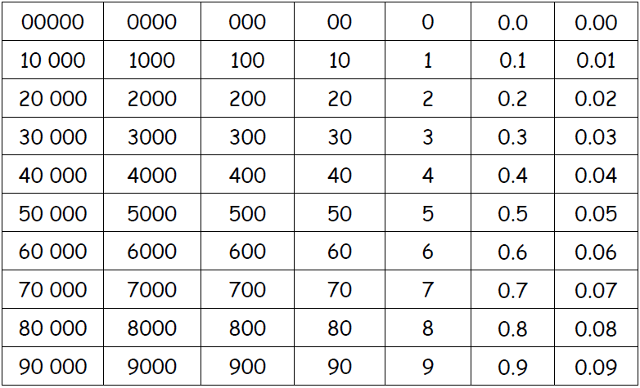

They then move each counter three places to the left to multiply the number by 1000 because 1000 is 10 x 10 x 10



*Examples of calculations*

75.91 x 10

5.07 x 10

670.4 x 100

360 x 1000

0.76 x 1000

*Prerequisite skills:*

* Partition a number into thousands, hundreds, tens, ones, tenths and hundredths
* Recombine multiples of a hundred thousand, ten thousand, thousand, hundred, ten, one and tenth

***Use related facts to multiply Th000 by a one-digit number***

*NB Th000 represents a multiple of 1000*

Children should be encouraged to identify the **relationships** between numbers in multiplication calculations, e.g. 6 x 8 = 48 could be represented using a multiplication trio as this model allows children to see the **relationships** between the numbers:

48

6

8

This can be used to derive the following calculations:

6 x 8 = 48

8 x 6 = 48

Children can then use the multiplication trio to derive related facts, e.g. 6000 x 8 =

48 000

6000

8

Children should be able to explain that because 6000 is one thousand times greater than 6, the answer to 6000 x 8 will be one thousand times greater than 48. They can then use their understanding of multiplying by 1000 to calculate this.

*Examples of calculations*

3000 x 3

7000 x 5

8000 x 9

*Prerequisite skills:*

* Recall multiplication tables
* Understand the effect of multiplying a one- or two-digit number by 1000

***Use related facts to multiply 0.t by a one-digit number***

*NB 0.t represents a multiple of a tenth*

The multiplication trio from the previous strategy can also be used to derive 0.t multiplied by a one-digit number, e.g. 0.6 x 8

4.8

0.6

8

Children should be able to explain that because 0.6 is ten times smaller than 6, the answer to 0.6 x 8 will be ten times smaller than 48. They can then use their understanding of dividing by 10 to calculate this.

*Examples of calculations*

0.3 x 7

0.6 x 9

0.5 x 4

*Prerequisite skills:*

* Recall multiplication tables
* Understand the effect of dividing a one- or two-digit number by 10

***Use factor pairs to multiply T0 x T0***

Calculations that involve multiplying T0 x T0 can be broken down into smaller steps by using factor pairs.

e.g. 60 x 40 =

becomes 6 x 10 x 4 x 10 = (using knowledge of factor pairs)

which becomes 6 x 4 x 10 x 10 = (using knowledge of commutativity/associativity)

which becomes 24 x 100 = 2400

*Examples of calculations*

30 x 60

70 x 80

50 x 40

*Prerequisite skills:*

* Recall multiplication tables
* Understand the effect of multiplying a one- or two-digit number by 100
* Recognise and use factor pairs

***Use compensation to multiply H99 by a one-digit number***

*NB H99 represents a three-digit number with 9 tens and 9 ones*

Building on their understanding from Year 4 of multiplying T9 by a one-digit number, children multiply by the nearest multiple of a hundred and then compensate appropriately.

e.g. 699 x 3 =

699 x 3 = 700 x 3 subtract 1 x 3

700 x 3 = 2100

So 699 x 3 = 2100 – 3 (one group of 3 less than 2100)

699 x 3 = 2097

*Examples of calculations*

599 x 4

399 x 7

699 x 9

*Prerequisite skills:*

* Recall multiplication tables
* Understand how multiplying by 99 is related to multiplying by 100
* Use related facts to multiply H00 by a one-digit number
* Subtract a one-digit number from a multiple of a hundred

***Use partitioning to multiply U.t by a one-digit number***

Children should be encouraged to choose the most efficient method, which may be mental, rather than simply opting for a written method.

e.g. 3.8 x 4 =

3 x 4 = 12

0.8 x 4 = 3.2

3.8 x 4 = 15.2

*Examples of calculations*

6.7 x 4

3.2 x 7

8.5 x 6

*Prerequisite skills:*

* Recall multiplication tables
* Partition U.t into ones and tenths
* Use related facts
* Add numbers with different amounts of digits

***Use partitioning to double numbers including those with two decimal places***

Children should use related facts to double numbers. For example, double 9 is 18 so double 0.09 (a hundred times smaller than 9) is 0.18 (a hundred times smaller than 18).

e.g. double 7.86

7.86

0.06

7

0.8

0.12

14

1.6

15.72

The diagram above illustrates the way children should be thinking about doubling using partitioning, but it is not necessary for them to record in this way if it is not helpful to the child.

*Examples of calculations*

Double 56.7

Double 485.6

Double 8.59

Double 36 742

*Prerequisite skills:*

* Count forwards in hundredths, tenths, ones, tens, hundreds and thousands
* Partition a number into thousands, hundreds, tens, ones, tenths and hundredths
* Use related facts to double multiples of hundredths, tenths, ones, tens, hundreds and thousands
* Recombine multiples of hundredths, tenths, ones, tens, hundreds and thousands

**Divide numbers mentally drawing upon known facts**

***Divide whole numbers and decimals by 10, 100 and 1000 using a place value chart***

Building on their knowledge of dividing by 10 and 100 from Year 3 and Year 4, children can use transparent counters to help them develop their understanding of dividing numbers by 10, 100 and 1000. Answers should include decimals up to two decimal places.

e.g. 35 600 ÷ 1000 =

The children represent 35 600 on a place value chart using transparent counters.



They then move each counter three places to the right to divide the number by 1000

1000 is 10 x 10 x 10 so dividing by 1000 is the same as ÷ 10 ÷ 10 ÷ 10



*Examples of calculations*

874 ÷ 10

60.1 ÷ 10

7043 ÷ 100

48 750 ÷ 1000

*Prerequisite skills:*

* Partition a number into hundred thousands, ten thousands, thousands, hundreds, tens, ones and tenths
* Recombine multiples of ten thousand, thousand, hundred, ten, one, tenth and hundredth

***Use related facts to divide ThH00 by a one-digit number***

*NB ThH00 represents a four-digit multiple of 100*

Children should be encouraged to identify the **relationships** between numbers in division calculations, e.g. 54 ÷ 6 = 9 could be represented using a division trio:

54

9

6

This can be used to derive the following calculations:

54 ÷ 6 = 9

54 ÷ 9 = 6

Children can then use the division trio to derive related facts, e.g. 5400 ÷ 6 = 900

5400

900

6

Children should be able to explain that because 5400 is a hundred times greater than 54, the answer to 5400 ÷ 6 will be a hundred times greater than 9. They can then use their understanding of multiplying by 100 to calculate this.

*Examples of calculations*

8100 ÷ 9

3000 ÷ 6

9600 ÷ 8

*Prerequisite skills:*

* Recall multiplication tables
* Understand the effect of multiplying a one or two-digit number by 100

***Use related facts to divide U.t by a one-digit number***

The division trio from the previous strategy can also be used to derive U.t divided by a one-digit number, e.g. 5.4 ÷ 6 =

5.4

6

0.9

Children should be able to explain that because 5.4 is ten times smaller than 54, the answer to 5.4 ÷ 6 will be ten times smaller than 9. They can then use their understanding of dividing by 10 to calculate this.

*Examples of calculations*

2.1 ÷ 7

3.6 ÷ 9

4.8 ÷ 4

*Prerequisite skills:*

* Recall multiplication tables
* Understand the effect of dividing a one- or two-digit number by 10

***Use related facts to divide U.t by a 0.t***

The division trio from the previous strategy can also be used to derive U.t divided by 0.t, e.g. 5.4 ÷ 0.6 =

5.4

9

0.6

Children should be able to explain that 5.4 is ten times smaller than 54 and 0.6 is ten times smaller than 6. This means that both numbers have been scaled down by the same amount, so the relationship between the numbers stays the same. The answer to 5.4 ÷ 0.6 will therefore be 9 because there are 9 groups of 0.6 in 5.4

*Examples of calculations*

2.1 ÷ 0.7

3.6 ÷ 0.9

4.8 ÷ 0.4

*Prerequisite skills:*

* Recall multiplication tables
* Understand division as repeated subtraction

***Use partitioning to divide HTU by a one-digit number***

Building on their understanding of using partitioning to divide TU by a one-digit number from Year 4, children decide how to partition HTU to help them divide it by a one-digit number.

e.g. 942 ÷ 6 = **157**

342

600 ÷ 6 = **100**

300 ÷ 6 = **50**

600

942

300

42

42 ÷ 6 = **7**

The diagram above illustrates the way children should be thinking about dividing using partitioning, but it is not necessary for them to record in this way if it is not helpful to the child.

*Examples of calculations*

756 ÷ 9 By partitioning into 720 and 36

765 ÷ 5 By partitioning into 500 and 250 and 15

861 ÷ 7 By partitioning into 700 and 140 and 21

*Prerequisite skills:*

* Recall multiplication tables
* Understand division as repeated subtraction
* Partition three-digit numbers in different ways

***Use partitioning to halve any number including to two decimal places***

Children should be encouraged to decide the best way to partition a number to halve it.

e.g. Find half of 6.74

6

6.74

0.04

0.02

0.35

0.7

3

3.37

An alternative way of partitioning would be:

Find half of 6.74

6.74

6.6

0.14

3.3

0.07

3.37

The diagrams above illustrate the way children should be thinking about halving using partitioning, but it is not necessary for them to record in this way if it is not helpful to the child.

*Examples of calculations*

Find half of 4.62

Find half of 18.46

Find half of 8.94

Find half of 17.92

Find half of 32 784

*Prerequisite skills:*

* Partition numbers (including in different ways for efficiency)
* Use related facts to halve a multiple of a hundredth, tenth, ten, hundred and thousand
* Recombine multiples of one, ten, hundred and thousand
* Recombine multiples of a tenth and a hundredth

**Y6**

**End of Year Objective:**

***Perform mental calculations, including with mixed operations and large numbers***

**Rapid Recall**

Children should be able to:

* Recall related tables facts decimal numbers (0.7 x 6 = 4.2 because 7 x 6 = 42)
* Use partitioning to double or halve any number
* Recall prime numbers up to 100
* Recall squares of the corresponding multiples of 10 (i.e. 40² is 1600)

**Mental Strategies**

In Year 6 children build on their skills and understanding from previous year groups to multiply and divide mentally with larger numbers and numbers to three decimal places. Children should be encouraged to choose the most appropriate strategy based on the numbers involved in the calculation.

**Perform mental calculations – Multiplication**

***Multiply whole numbers and decimals to three decimal places by 10, 100 and 1000***

Building on their knowledge of multiplying by 10, 100 and 1000 from Year 5, children use place value columns to multiply numbers to three decimal places by 10, 100 and 1000

e.g. 43.721 x 100 =

Th H T U t h th

4 3 7 2 1

4 3 7 2 1



*Examples of calculations*

4562 x 1000

9.682 x 10

25.784 x 100

*Prerequisite skills:*

* Understand and use place value columns when representing numbers
* Understand the effect of multiplying a number by 10, 100 or 1000

***Identify and use all related facts that link to tables***

Children should be encouraged to select the most appropriate strategy based on the numbers involved in the calculation.

e.g. 8000 x 4 =

Using related facts in a multiplication trio could help with this calculation:

32 000

8000

4

Children should be able to explain that because 8000 is a thousand times greater than 8, the answer to 8000 x 4 will be a thousand times greater than 32.

e.g. 8000 x 40 =

Using factor pairs could help with this calculation:

8000 x 40 =

becomes 8000 x 4 x 10 = (using knowledge of factor pairs)

which becomes 32 000 x 10 = 320 000

*Examples of calculations*

7000 x 6

500 x 40

900 x 300

3000 x 80

*Prerequisite skills:*

* Recall multiplication tables
* Understand the effect of multiplying a number by 10, 100 or 1000
* Recognise and use factor pairs

***Use related facts to multiply 0.0t by a one-digit number***

*NB 0.0t represents a multiple of a hundredth*

Children can use a multiplication trio to derive related facts, e.g. 0.07 x 4

0.28

0.07

4

Children should be able to explain that because 0.07 is a hundred times smaller than 7, the answer to 0.07 x 4 will be a hundred times smaller than 28. They can then use their understanding of dividing by 100 to calculate this.

*Examples of calculations*

0.03 x 7

0.06 x 9

0.05 x 4

*Prerequisite skills:*

* Recall multiplication tables
* Understand the effect of dividing a one- or two-digit number by 100

***Use compensation to multiply U.9 and U.99 by a one-digit number***

Building on their understanding from Year 5 of multiplying H99 by a one-digit number, children multiply by the nearest whole number and then compensate appropriately.

e.g. 6.9 x 4 =

6.9 x 4 = 7 x 4 subtract 0.1 x 4

7 x 4 = 28

So 6.9 x 4 = 28 – 0.4

6.9 x 4 = 27.6

e.g. 6.99 x 4 =

6.99 x 4 = 7 x 4 subtract 0.01 x 4

7 x 4 = 28

So 6.99 x 4 = 28 – 0.04

6.99 x 4 = 27.96

*Examples of calculations*

5.9 x 4

3.99 x 7

9.99 x 6

*Prerequisite skills:*

* Recall multiplication tables
* Understand how multiplying by 0.9 is related to multiplying by 1
* Understand how multiplying by 0.99 is related to multiplying by 1
* Subtract a 0.t or 0.0h from a whole number

***Use partitioning to multiply 0.th by a one-digit number***

Children should be encouraged to choose the most efficient method, which may be mental, rather than simply opting for a written method.

e.g. 0.67 x 4 =

0.6 x 4 = 2.4

0.07 x 4 = 0.28

0.67 x 4 = 2.68

*Examples of calculations*

0.76 x 3

0.28 x 7

0.54 x 6

*Prerequisite skills:*

* Recall multiplication tables
* Partition 0.th into tenths and hundredths
* Use related facts
* Add numbers with different amounts of digits

***Use partitioning to double numbers including those with three decimal places***

Children should use related facts to double numbers. For example, double 9 is 18 so double 0.009 (a thousand times smaller than 9) is 0.018 (a thousand times smaller than 18).

e.g. double 6.374

6.374

0.004

0.07

0.3

6

0.008

0.14

0.6

12

12.748

The diagram above illustrates the way children should be thinking about doubling using partitioning, but it is not necessary for them to record in this way if it is not helpful to the child.

*Examples of calculations*

Double 3.421

Double 6.705

Double 12.594

Double 54 672

Double 674 960

*Prerequisite skills:*

* Count forwards in steps of powers of 10
* Partition a number appropriately
* Use related facts to double multiples of powers of 10
* Recombine multiples of powers of 10

**Perform mental calculations – Division**

***Divide whole numbers and decimals to three decimal places by 10, 100 and 1000***

Building on their knowledge of dividing by 10, 100 and 1000 from Year 5, children use place value columns to divide numbers by 10, 100 and 1000. Answers should include decimals up to three decimal places.

e.g. 356.7 ÷ 100 =

Th H T U t h th

3 5 6 7

3 5 6 7



*Examples of calculations*

9.83 ÷ 10

7.04 ÷ 10

860.2 ÷ 100

56 789 ÷ 1000

*Prerequisite skills:*

* Understand and use place value columns when representing numbers
* Understand the effect of dividing a number by 10, 100 or 1000

***Identify and use all related facts that link to tables***

Children should be encouraged to select the most appropriate strategy based on the numbers involved in the calculation.

e.g. 56 000 ÷ 8 =

Using related facts in a division trio could help with this calculation:

56 000

7000

8

Children should be able to explain that because 56 000 is a thousand times greater than 56, the answer to 56 000 ÷ 8 will be a thousand times greater than 7. They can then use their understanding of multiplying by 1000 to calculate this.

e.g. 5600 ÷ 80 =

The following division trio could be used as a starting point for this calculation:

5600

8

700

Children should be able to explain that because 5600 is a hundred times greater than 56, the answer to 5600 ÷ 8 will be a hundred times greater than 7. They can then use their understanding of multiplying by 100 to calculate this.

The following division trio could then be derived:

5600

80

70

Children should be able to explain that because 80 is ten times greater than 8, the answer to 5600 ÷ 80 will be ten times smaller than the answer to 5600 ÷ 8 because there will be ten times fewer groups.

*Examples of calculations*

81 000 ÷ 9

270 ÷ 30

3000 ÷ 50

9600 ÷ 800

*Prerequisite skills:*

* Recall multiplication tables
* Understand division as repeated subtraction
* Understand the effect of multiplying or dividing by 10, 100 or 1000

***Use related facts to divide TU by 0.t***

e.g. 56 ÷ 0.8 =

Using related facts in a division trio could help with this calculation:

56

0.8

70

Children should be able to explain that because 0.8 is ten times smaller than 8, the answer to 56 ÷ 0.8 will be ten times greater than the answer to 56 ÷ 8 because there will be ten times more groups.

*Examples of calculations*

21 ÷ 0.7

36 ÷ 0.9

48 ÷ 0.4

*Prerequisite skills:*

* Recall multiplication tables
* Understand division as repeated subtraction
* Understand the effect of multiplying or dividing by 10

***Use related facts to divide 0.th by 0.t***

e.g. 0.54 ÷ 0.6 =

The following division trio from Year 5 could be used as a starting point for this calculation:

5.4

0.6

9

Children should be able to explain that 5.4 is ten times smaller than 54 and 0.6 is ten times smaller than 6. This means that both numbers have been scaled down by the same amount, so the relationship between the numbers stays the same. The answer to 5.4 ÷ 0.6 will therefore be 9 because there are 9 groups of 0.6 in 5.4

The following division trio could then be derived:

0.54

0.6

0.9

Children should be able to explain that because 0.54 is ten times smaller than 5.4, the answer to 0.54 ÷ 0.6 will be ten times smaller than 9. They can then use their understanding of dividing by 10 to calculate this.

*Examples of calculations*

0.32 ÷ 0.4

0.64 ÷ 0.8

0.45 ÷ 0.9

*Prerequisite skills:*

* Recall multiplication tables
* Understand division as repeated subtraction
* Understand the effect of multiplying and dividing by 10

***Use related facts to divide by 50***

Dividing by 50 is the same as dividing by 100 and then doubling because 50 is half of 100. Children can investigate this using simple calculations.

e.g. 200 ÷ 100 = 2

2 x 2 = 4

So 200 ÷ 50 = 4

Children can then use this in more complex calculations.

e.g. 3200 ÷ 50 =

3200 ÷100 = 32

32 x 2 = 64

So 3200 ÷ 50 = 64

*Examples of calculations*

4100 ÷ 50

7800 ÷ 50

530 ÷ 50

*Prerequisite skills:*

* Understand the effect of dividing by 100
* Double numbers including those with one decimal place

***Use related facts to divide by 25***

Dividing by 25 is the same as dividing by 100 and then multiplying by 4 because 25 is one quarter of 100. Children can investigate this using simple calculations.

e.g. 200 ÷ 100 = 2

2 x 4 = 8

So 200 ÷ 25 = 8

Children can then use this in more complex calculations.

e.g. 4800 ÷ 25 =

4800 ÷100 = 48

48 x 4 = 192

So 4800 ÷ 25 = 192

*Examples of calculations*

3200 ÷ 25

7600 ÷ 25

360 ÷ 25

*Prerequisite skills:*

* Understand the effect of dividing by 100
* Multiply numbers up to one decimal place by 4

***Use partitioning to divide ThHTU by a one-digit number***

Building on their understanding of using partitioning to divide TU by a one-digit number from Year 4, children decide how to partition ThHTU to help them divide it by a one-digit number.

e.g. 7505 ÷ 5 = **1501**

7505

48

5

2500

5000

5 ÷ 5 = **1**

2500 ÷ 5 = **500**

5000 ÷ 5 = **1000**

The diagram above illustrates the way children should be thinking about dividing using partitioning, but it is not necessary for them to record in this way if it is not helpful to the child.

*Examples of calculations*

5035 ÷ 5 By partitioning into 5000 and 35

1236 ÷ 4 By partitioning into 1200 and 36

9240 ÷ 6 By partitioning into 6000 and 3000 and 240

*Prerequisite skills:*

* Recall multiplication tables
* Understand division as repeated subtraction
* Partition four-digit numbers in different ways

***Use partitioning to halve any number including to three decimal places***

Children should be encouraged to decide the best way to partition a number to halve it.

e.g. Find half of 8.654

8.654

0.004

0.05

0.6

8

0.025

0.002

0.3

4

4.327

An alternative way of partitioning would be:

Find half of 8.654

8.654

8.6

0.04

0.014

4.3

0.02

0.007

4.327

The diagrams above illustrate the way children should be thinking about halving using partitioning, but it is not necessary for them to record in this way if it is not helpful to the child.

*Examples of calculations*

Find half of 4.684

Find half of 12.826

Find half of 6.942

Find half of 15.674

Find half of 478 612

*Prerequisite skills:*

* Partition numbers (including in different ways for efficiency)
* Use related facts to halve a multiple of a thousandth, hundredth, tenth, ten, hundred and thousand
* Recombine multiples of one, ten, hundred and thousand
* Recombine multiples of a tenth, hundredth and thousandth