Year 4 Homework – Starling class and Kingfisher class
Date homework set: Thursday 19th October 2023
To be returned to school by: Tuesday 2nd November 2023
Talking Topic (10 min)
With a friend or family member, discuss what you have enjoyed so far about being in Year 4. What have you learned? What have your proud moments been so far?
Tick when you have completed this task.
Maths (10 min)
This year, Year 4 children will be taking part in the Multiplcation Maths Check. Therefore, we would like them to practice their times tables as much as possible so that they are confident when the check comes around.
Please use the link below to practice as it is a similar format to the one used during the formal check.
MTC Test - URBrainy

We have been choosing appropriate methods for addition and subtraction problems this week.
For the following questions, which method would you use and explain your thinking.

- 230 + 400 = B) 378 + 378 = C) 560 – 216 = D) 875 - 319= E) 200 + 460 =

(HINT: numberline, mentally, collumn, partitioning)
Tick when you have completed this task.

English
Write a 500-word story for the BBC Writing Competition (discussed in class and explained further on the handout)
Here at 500 Words we want children to have fun writing their stories, be as creative as they can and make us laugh, cry or just be blown away by what we are reading. Over the years there have been incredible stories submitted. There are very few rules on 500 Words but a few points to remember:
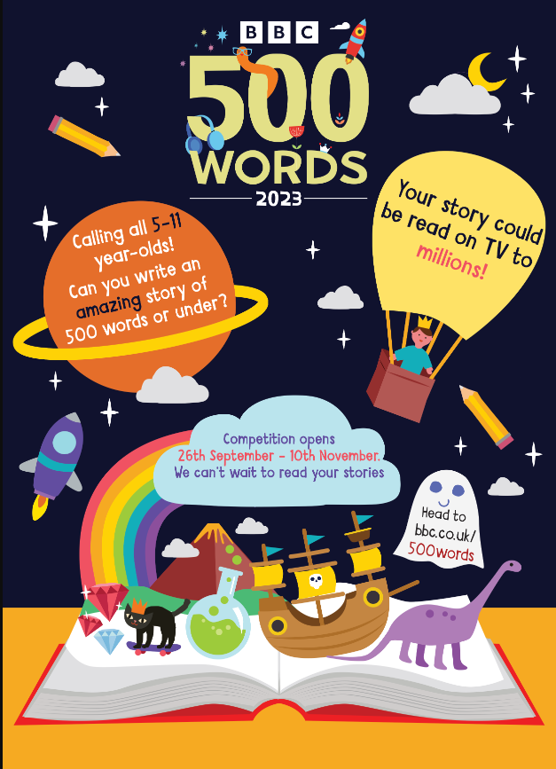
All the stories must:
- Be 500 words or less (title is not included in the number)
- Be written by an individual and not a group
- Be a child’s own original idea
- Be prose, not rap or poem
Tick when you have completed this task.
Other tasks that could be completed;
. Practice Year 3/4 spellings.
. Times Tables Rockstar’s
. Purple Mash
. My Maths
. Read your reading book or Reading for Pleasure book.
. Complete the reading for pleasure book marks.
. Spag.com
. Bug Club

