Year 4 Homework – Starling class and Kingfisher class
Date homework set: Thursday 16th November 2023
To be returned to school by: Tuesday 21st November 2023
Talking Topic (10 min)
Talk to a friend or family member about the charities we have helped over the past couple of weeks.
- Remembrance Day
- Hope for Mankind
- Children in Need

Tick when you have completed this task.
Maths (10 min)
This year, Year 4 children will be taking part in the Multiplcation Maths Check. Therefore, we would like them to practice their times tables as much as possible so that they are confident when the check comes around.
Please use the link below to practice as it is a similar format to the one used during the formal check.
MTC Test - URBrainy

We have been looking at the chunking method for division. Have a go at explaining to an adult how to work out the following.
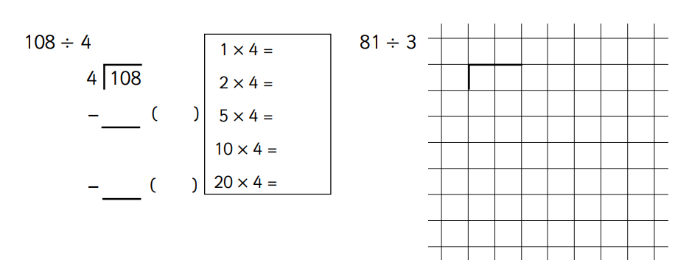
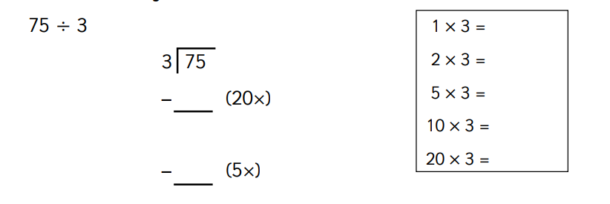

Tick when you have completed this task.

English
Using the pictures below, write down 3 possible fronted adverbials for time or place for each.
Example: During the afternoon, the boys and girls went to the park. At the park, the boys and girls had lots of fun!

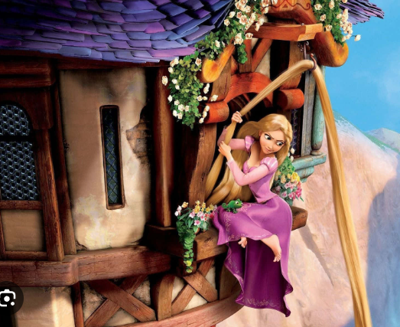

Tick when you have completed this task.
Other tasks that could be completed;
. Practice Year 3/4 spellings.
. Times Tables Rockstar’s
. Purple Mash
. My Maths
. Read your reading book or Reading for Pleasure book.
. Complete the reading for pleasure book marks.
. Spag.com
. Bug Club

