Year 4 Homework – Starling class and Kingfisher class
Date homework set: Thursday 23rd November 2023
To be returned to school by: Tuesday 28th November 2023
Talking Topic (10 min)
Talk to a friend or family member about everything you have learnt about the Plague so far in our History topic. When did it begin? What were the different types of plague? What were the different jobs roles back then e.g. the watcher, plague doctor, the bellman. What would it have been like living back in those days?

Tick when you have completed this task.
Maths (10 min)
This year, Year 4 children will be taking part in the Multiplcation Maths Check. Therefore, we would like them to practice their times tables as much as possible so that they are confident when the check comes around.
Please use the link below to practice as it is a similar format to the one used during the formal check.
MTC Test - URBrainy
This week, we have been looking at telling the time using a 24-hour clock (analogue and digital)

What time are the clocks? (am) What time are the clocks? (pm)

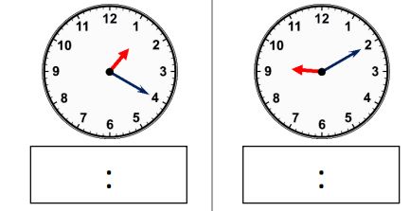
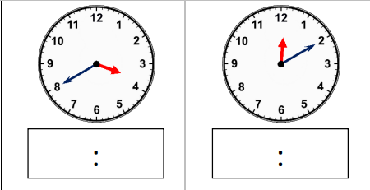

English (10 mins)
Research one of the following animals – we will be using them as part of our English lessons next week.

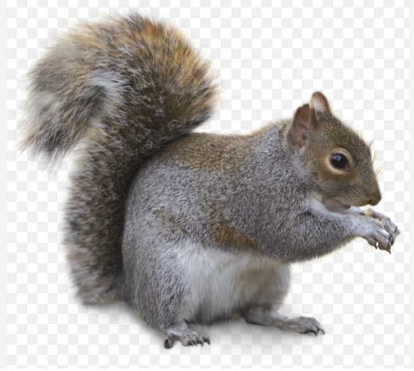
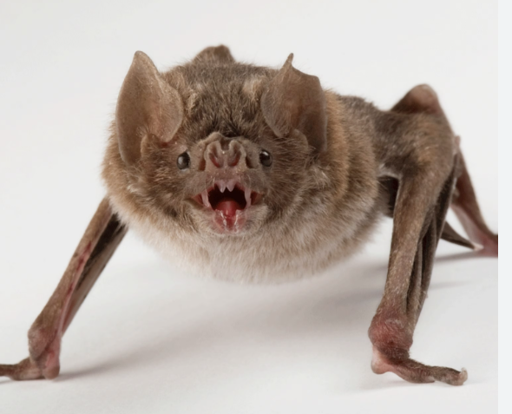
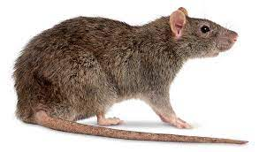

A bat
A squirrel
A rat
Tick when you have completed this task
. Other tasks that could be completed;
. Practice Year 3/4 spellings.
. Times Tables Rockstar’s
. Purple Mash
. My Maths
. Read your reading book or Reading for Pleasure book.
. Complete the reading for pleasure book marks.
. Spag.com
. Bug Club

