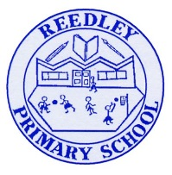
Year 5 Homework

Date homework set: 7.12.23
To be returned to school by: 12.12.23

Talking Topic
- To discuss the following topic:
“How do we do area in Maths?”

Tick when you have completed this task.
Maths Complete and learn the following;
Using the information above calculate the area of the shape below.
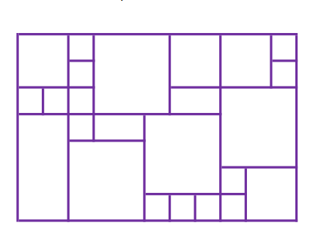
- Complete Times tables Rock Stars.
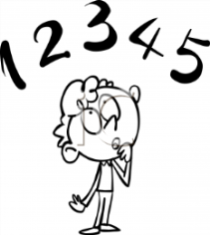
Tick when you have completed these tasks.
Reading
- Read the next chapter from your new reading for pleasure book.
- Read a book on Bug Club
- Continue with your next book mark.
- Read to an adult and ask them to sign your Reading Diary.
Tick when you have completed this task.

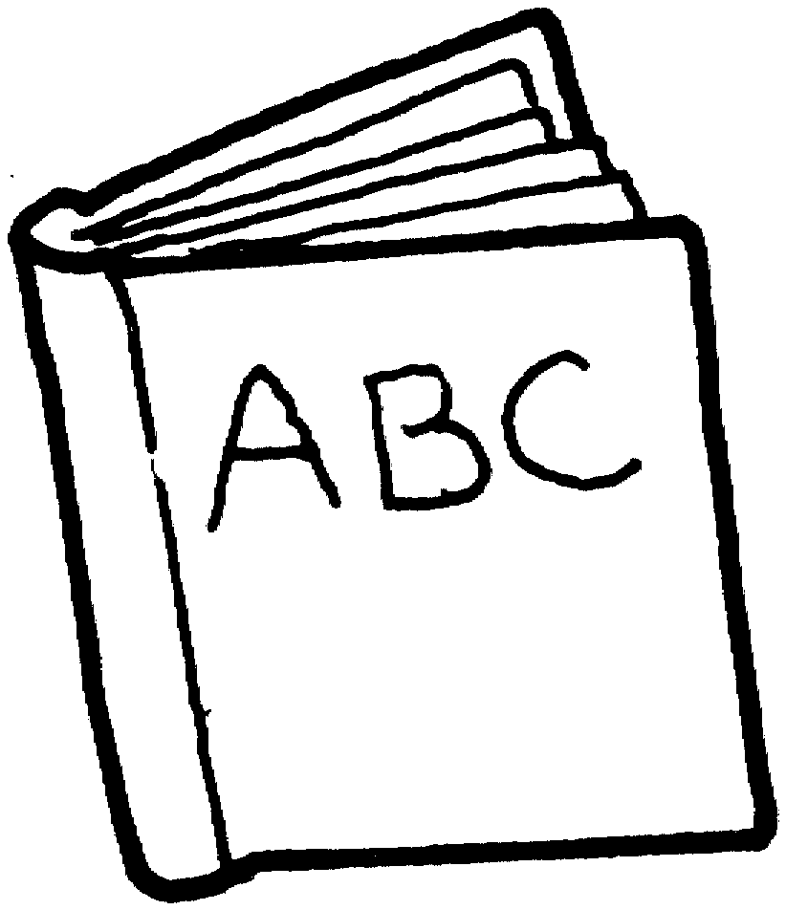
Spelling
Learn this week’s spellings.
Learn the five spellings below, using the pyramid method.
soldier stomach symbol system ancient
Tick when you have completed this task.
Spag.
Complete the activity below.
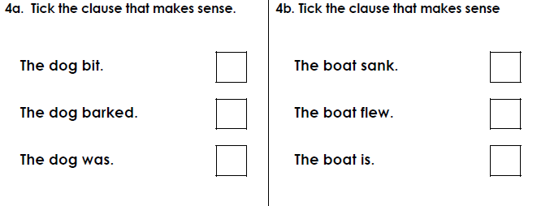

Writing
Write a letter to the Jabberwocky, explaining how disappointed you are.
Key Skill: Relative clause- which.
Tick when you have completed this task.

