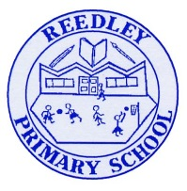
Year 5 Homework

Date homework set: 14.12.23
To be returned to school by: 19.12.23
When completing your homework try and do a little every day and not all at once.
Talking Topic
- To discuss the following topic:
- “Who celebrates Christmas?”
Tick when you have completed this task.
Maths Complete and learn the following;
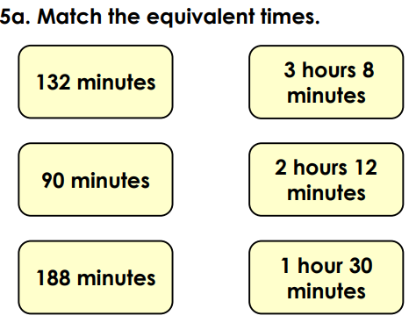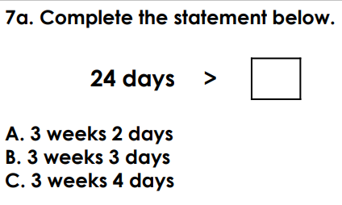
- Times tables Rock Stars.
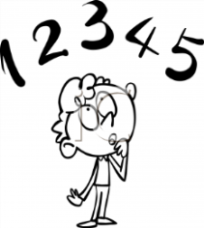
Tick when you have completed these tasks.
Reading
- Read the next chapter from your new reading for pleasure book.
- Read a book on Bug Club
- Continue with your next book mark.
- Read to an adult and ask them to sign your Reading Diary. Your reading diary will be checked.
Tick when you have completed this task.
Spelling: Learn this week’s spellings and include each one in a sentence.
Defensive
Refine
Microscope
Telescope.

Tick when you have completed this task.
Research: I want you to research the Beatles and create a presentation about this well know pop group. .
Tick when you have completed this task.

