Solar System Vocabulary |  | Science Fiction – |  | Art
Asteroid | A small rocky body orbiting the sun | Science Fiction text | Science fiction text involve  Science fiction often involves space travel.  Often there are cool machines like robots…  Sometimes the story is set in the future. | Abstract | Abstract Art has no subject.  It is just lines, shapes, and colours. 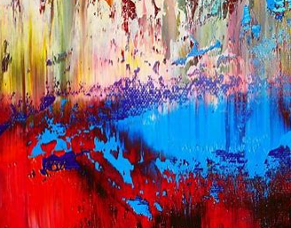
Axis | An imaginary line about which a body rotates | Cohesive  devices | furthermore, nevertheless, also, in addition to, contrary to, despite, as well as, on the other hand,  without warning, | Wassily Kandinsky | Wassily Kandinsky, Russian-born artist, one of the first creators of pure abstraction in modern painting.  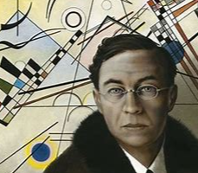
Moon | A natural satellite of any planet | Story openers | Speech- “Planet Zedo is our destination” explained Captain Smith.  Character description- The enormous, green dragon was covered in shiny scales.  Setting description- Millions of twinkling stars lit up the black blanket of sky.  Action- Laser beams were shooting across from every angle! | Jackson Pollock | Jackson Pollock was an influential American painter, and the leading force behind the abstract expressionist movement in the art world.  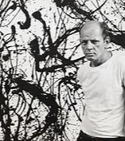
Planet | A celestial body moving in orbit round a star | How do the Earth, Sun and Moon fit within our solar system?
Celestial | Positioned in or relating to the sky, or outer space as observed in the astronomy | 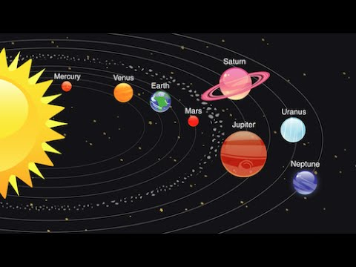
Heliocentric | Representing the sun as the centre of the solar system, the modern view of the solar system
Star | Star A fixed luminous point in the night sky which is a large, remote body like the sun

