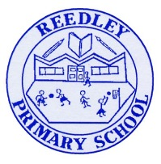
Year 4 Homework – Starling class and Kingfisher class
Date homework set: Thursday 7th December 2023
To be returned to school by: Tuesday 12th December2023
Talking Topic (10 min)
Talk to a friend or family member about somebody who makes you happy. Who makes your smile all the time? Who is there to support you? Who are you thankful for?

Tick when you have completed this task.
Maths (10 min)
This year, Year 4 children will be taking part in the Multiplcation Maths Check. Therefore, we would like them to practice their times tables as much as possible so that they are confident when the check comes around.
Please use the link below to practice as it is a similar format to the one used during the formal check.
MTC Test - URBrainy
This week, we have been looking at shape. We have identified parallel lines, right angles and have explored the number of edges, faces and vertices 3D shapes.
True or false?
This shape is a pyramid
It has got 0 faces
It is a 3-D shape
It has got 3 straight edges
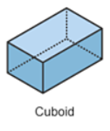
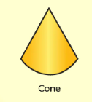
- Write down the properties of this shape

English (10 mins)
You are now the teacher for this task! Can you re-write this paragraph so that it makes sense. Think about spelling, punctuation and grammar.

At that moment the dredful which played a nasty trick on snow white. The which pretended to be a sweet innocent old Lady and gave her a apple to bite into. Snow white didnt know it was full of poison Poor snow white took one big bite out of the apple and slowly fell to the ground like a waterfall plummeting from a mountain. The which cackled with joy

Tick when you have completed this task
. Battle of the classes!
Year 4 TTRockstars battle will take place from Thursday 7th December to Tuesday 12th December.

Good luck to both classes!

