Year 4 Homework – Starling class and Kingfisher class
Date homework set: Thursday 14th December 2023
To be returned to school by: Tuesday 19th December 2023
Talking Topic (10 min)
Would you prefer to live in a tree-house or an igloo?
Talk to a friend or family member about your choice ad explain why.

Tick when you have completed this task.
Maths (10 min)
This year, Year 4 children will be taking part in the Multiplcation Maths Check. Therefore, we would like them to practice their times tables as much as possible so that they are confident when the check comes around.
Please use the link below to practice as it is a similar format to the one used during the formal check.
MTC Test - URBrainy
This week, we have been recapping some skills we have learnt so far in Year 4. Can you create a mind map for some of the skills we have looked at? Perhaps just choose 3 or 4 topics to concentrate on.
Here are the topics we have studied so far to help you with your creation. Provide some examples within your mind map. For example, you could write down your own division problem, 346 divided by 5 and show me how you would work it out using the chunking method.

- Place value
- Length and perimeter
- Statistics (bar charts and data)
- Addition and subtraction
- Multiplication and division
- Time
- Shape

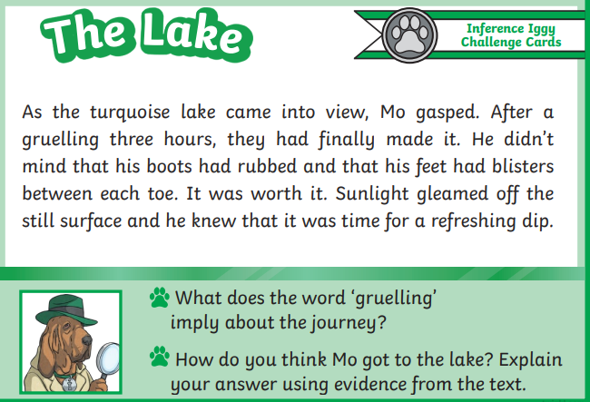
English (10 mins)

We are becoming great with our inference skills!
Can you have a go at these
inference questions once you have
read the short paragraph.

. Battle of the classes!
Year 4 TTRockstars battle will take place from Thursday 14th December to Tuesday 19th December.

Good luck to both classes!

