Wednesday 17th January 2024
KL – To make simple inferences
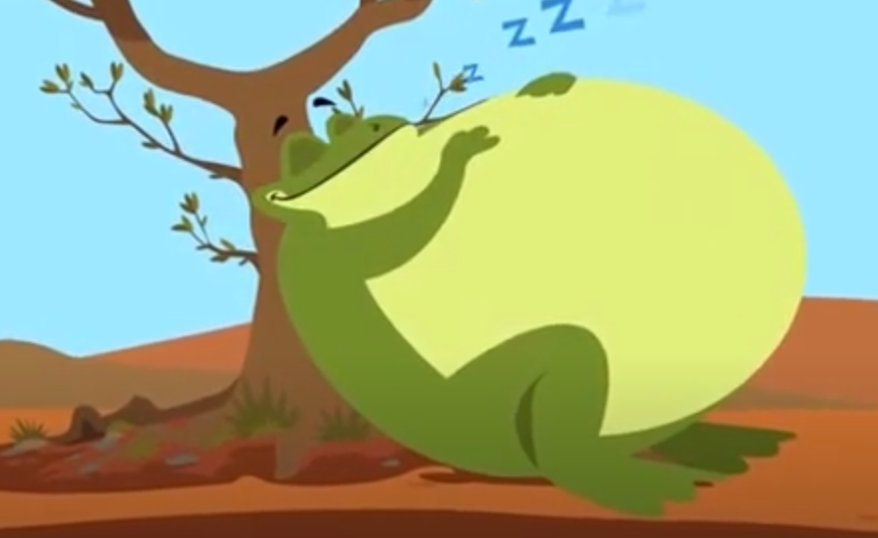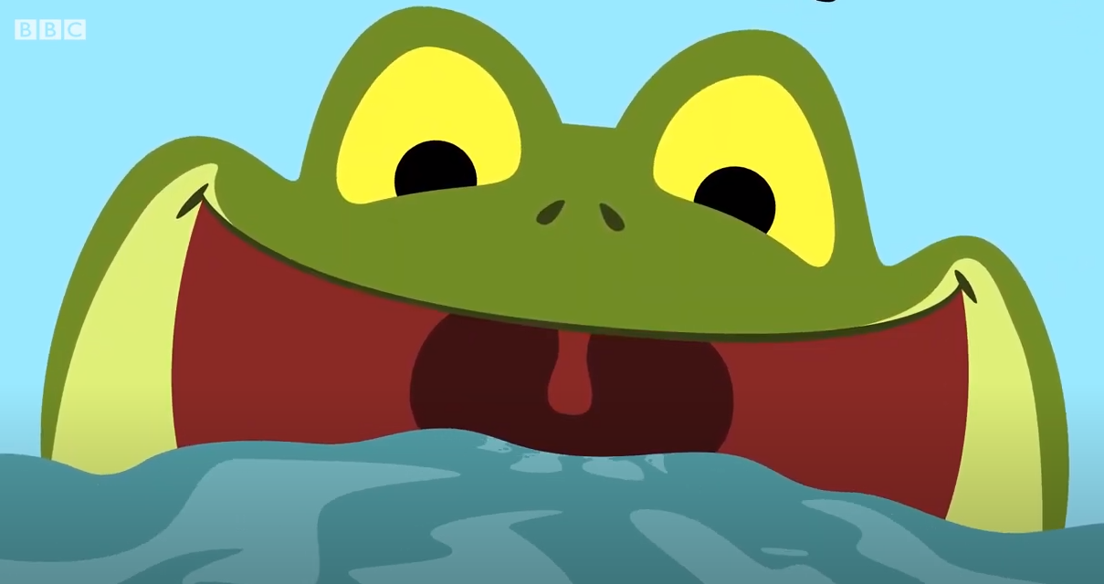

How is Tiddalik feeling?
__________________________________________
__________________________________________
__________________________________________
What is Tiddalik thinking?

__________________________________________
__________________________________________
__________________________________________

What might Tiddalik say?

_________________________________________
_________________________________________
_________________________________________

Wednesday 17th January 2024
KL – To make simple inferences
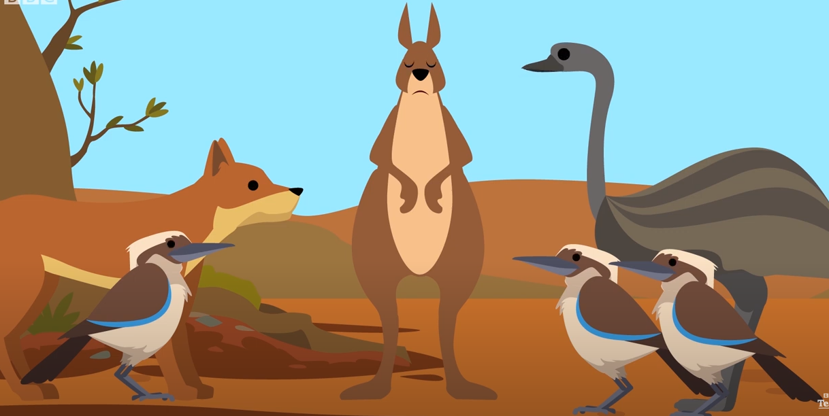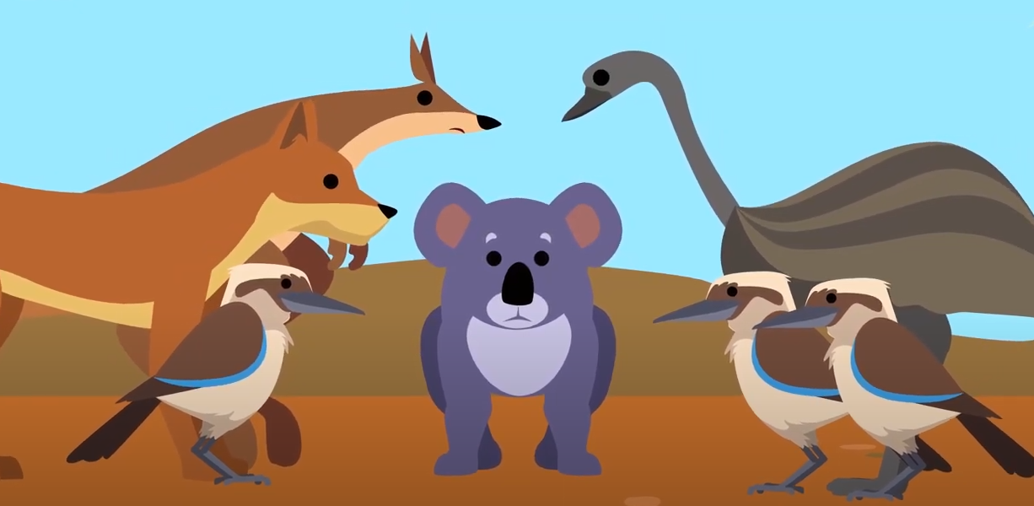

How are the other animals feeling?
__________________________________________
__________________________________________
__________________________________________

What are the other animals thinking?
__________________________________________
__________________________________________
__________________________________________

What might the other animals say?

_________________________________________
_________________________________________
_________________________________________

