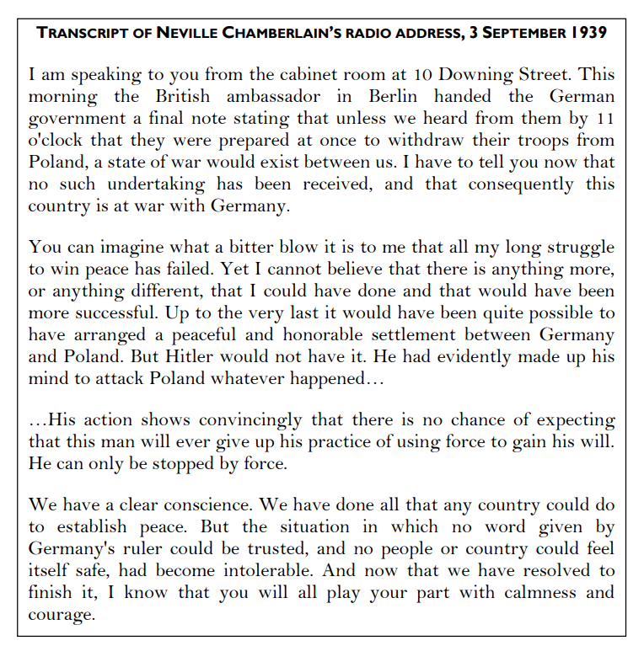
Britain declares war on Germany - BBC Teach

