Year 6 Homework

Date homework set: 18.01.2024
To be returned to school by: 23.1.2024

Talking Topic To discuss the following topic:
“What was the coldest temperature this week?” Tick when you have completed this task.
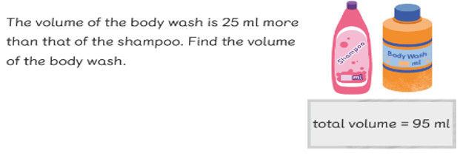
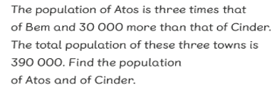
Maths

Don’t forget to complete My Maths activity: co-ordinates

Writing I want you to do some family research. Is there anyone in your family who has links to World War 2? Write what they did and interesting facts about them. Start with asking your parents or carers and see if they know. To make it more interesting, you can include a family tree.

Investigate four of the Year 5 and 6 spelling. Write their meanings in your Homework books.
I want you to research words which end in the suffix ’shun’. How many new ones can you find and what is their word meaning? I challenge you to find ten. Next, include the words in a new sentence.
Tick when you have completed this task.

Further resources to practice your skills can be found on;
My Maths - MyMaths
Spag.com- SPAG Tests Online
Timestable Rockstart- Times Tables Rock Stars (ttrockstars.com)

