Year 5 Homework

Date homework set: 22.2.24
To be returned to school by: 27.2.24
When completing your homework try and do a little every day and not all at once.
Talking Topic
- Talk to an adult about
- “What is a digital footprint”
- Tick when you have completed this task.
Reading
- Read the next chapter from your new reading for pleasure book.
- Read a book on Bug Club
- Continue with your next book mark.
- Read to an adult and ask them to sign your Reading Diary. Your reading diary will be checked.
Tick when
Spelling: Learn this week’s spellings and include each one in a sentence.
Queue
Temperature
Harass
Programme
Rhyme
Tick when you have completed this task.
Maths
Complete the following:
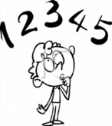
100 x 34.56 =
234 x 1000 =
7623.3 X 100 =
212 X _____ = 212000

Complete Times tables Rock Stars.
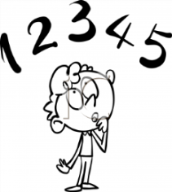
Tick when you have completed these tasks
Research:
Find out about the Islamic Golden Age.
When did it begin? What was the name of the Caliph?
Why was Baghdad important during this time?

Tick when you have completed this task.

