Year 5 Homework

Date homework set: 29.2.24
To be returned to school by: 5.3.24
hen completing your homework try and do a little every day and not all at once.
Talking Topic
- Talk to an adult about
- “How was Islam able to expand so far, so quickly after the death of the Prophet?”
- Use these key words: skillful fighters, amazing weapons, took opponents by surprise, believed God wanted them to spread message, merchants spread message
- Tick when you have completed this task.
Reading
- Read the next chapter from your new reading for pleasure book.
- Read a book on Bug Club
- Continue with your next book mark.
- Read to an adult and ask them to sign your Reading Diary. Your reading diary will be checked.
Tick when
Spelling: Learn this week’s spellings and include each one in a sentence.
sufficient
interrupt
opportunity
dictionary
restaurant
programme

Tick when you have completed this task.
Maths
Draw a poster to show the following rules.
Write some examples to show how the rule works

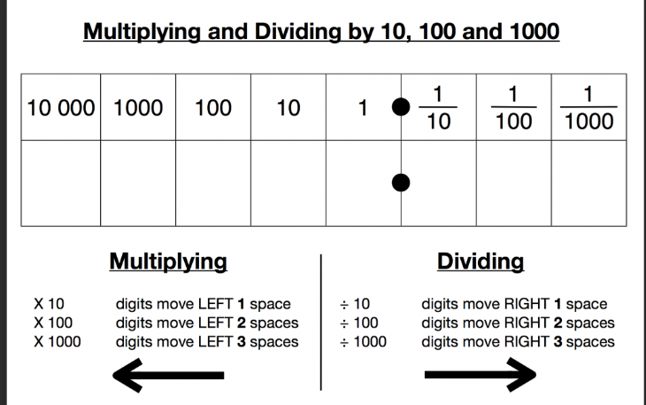
Complete Times tables Rock Stars.
Tick when you have completed these tasks
Research:
Find out about The House of Wisdom and why it was important?
Tick when you have completed this task.

