Year 5 Homework

Date homework set: 21.3.24
To be returned to school by: 26.3.24.
When completing your homework try and do a little every day and not all at once.
Talking Topic
- To discuss the following topic:
- “Where do we get our water from?”
Tick when you have completed this task.
Maths Complete the activity below. Complete The My Maths activity.
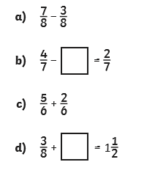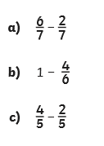
- Times tables Rock Stars.
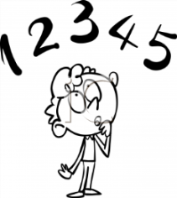
Tick when you have completed these tasks.
Reading
- Read the next chapter from your new reading for pleasure book.
- Read a book on Bug Club
- You must complete your bookmark this week.
- Read to an adult and ask them to sign your Reading Diary. Your reading diary will be checked.
Tick when you have completed this task.
SPAG.
Complete the SPAG.com activity below. Read the sentences below and add the missing inverted commas and any other missing punctuation.
Q1. Rewrite the sentence below as direct speech.
Remember to punctuate your sentence correctly.
I asked her if she needed any help.
I asked, ________________________________________

Q2. Which sentence uses inverted commas correctly?

Tick one.
“Mr Nelson asked, Who is responsible for the sports equipment?”
Mr Nelson asked, “Who is responsible for the sports equipment?”
“Mr Nelson asked,” Who is responsible for the sports equipment?
Mr Nelson asked, “Who is responsible for the sports equipment”?

Q3. Add the missing inverted commas to the passage below.
Maya whispered , I can see a baby hedgehog ! Keep
quiet so we don’t scare it .

Spelling
Read each sentence below and correct any incorrect spellings.
Tick when you have completed this task.
I want you to practise the homophone spellings below. Onece you have practised the pryramid method for each spelling, I want you to include the spelling in a sentence.
Accept/ except
Affect/ effect
Ball/ bawl
Berry/ bury
Knot/not
Short writing task.
I want you to come up with a new character for Hugo Cabret. I want you to decribe the character using expanded noun phrases.

Tick when you have completed this task.

