Thursday, 28 March 2024
Dear Parents/Carers,
I would like to wish all of our Muslim families Eid Mubarak.
I really hope that you all enjoy your celebrations during Eid.

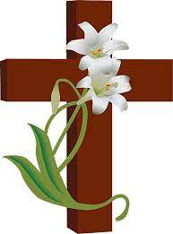
In assembly today we were able to watch a clip from BBC news where one of our pupils Adam Baig and his family were featured, sharing their experiences of fasting.

I would also like to wish a Happy Easter to our Christian families.

Sue Dean Award
Each half term a child in school is awarded the Sue Dean Writing Award. One child from each class is nominated by the teacher.
Imaani Aaamir in Year 3 is the overall winner of the award for this half term. Well done Imaani.

Awards
- We have a reading award system in school where children can carry out activities related to books and achieve certificates. If the children have been progressing through these tasks, their names go into a raffle and two children each half term will win a £10 book voucher.
Isa Umar in Reception and Abdul Rahim Khan in Y5 have won the vouchers this half term. Well done!
- All of the children with 96+% attendance this term have been entered into a raffle to win a board game.
These children were the lucky ones this time:
Scarlett Hartley in Reception, Saara Jamila Ali in Y1, Tasqeen Ali in Y4 and Habibah Afzal Y5.

Miss Veldon’s Y3 Golden Eagle class won the overall attendance award for the half term.
Mrs King’s Y1 Squirrel Class won the overall punctuality award for the half term.
Both of these classes will have a non-uniform day on Friday 19th April

Attendance
Our overall attendance for this week is 90.51%.
The children who achieved 96+% attendance throughout the Spring Term will be taking part in an attendance treat during the first week back.
Your child has been given their traffic light sheet in school today to show how their attendance has been this year and during the Spring Term.

Punctuality
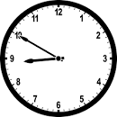
We had 6 hours and 35 minutes of lates this week, meaning vital learning is still being missed by some children. This is a slight improvement but we need all children to be in school by 8.50am each day.

Events This Week
- We had two visitors from Burnley FC in the Community on Monday. They spoke to the children in Y3 – 6 about girls in sport and they presented our girls’ football team with a new kit.

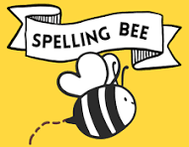

- Six children took part in the Spelling Bee semi-final at Walverden school on Monday.
Well done to:
Muhammad Ali Ahmed in Y1, Ali Shair in Y2, Maham Shakeel in Y3, Zakariya Ishtiaq in Y4, Abdul Rahim Khan in Y5 and Izaan Imran in Y6
Muhammad Ali, Maham and Izaan will be going through to the final during the summer term.

Y3 Eid Assembly
Year 3 children will be doing an Eid assembly on Friday 19th April at 2.45pm. Parents/carers from Y3 are welcome to attend. A letter has gone home with details of how you can send information to Mrs Ellis for the assembly, in preparation for the visit in April.

Parent Meetings
Thank you to everyone who was able to attend the parent/carer meeting with your child’s teacher this week. If you were unable to attend, you can call school and make an appointment to chat to your child’s teacher after the school break.

School Spider
If you find that you can’t access School Spider, in the first instance please go to the RESET YOUR PASSWORD link. Your username is your full name with no capital letters or spaces (not your child’s name).

Holiday Club
Please remember that you can book a place in our holiday club, which is run by the Wrap Around Club Providers. See details below. It sounds like it is going to be a very exciting few days!

Holiday Homework
Miss Radcliffe has set some battles on Times Table Rockstars for the school holidays. I can’t wait to see the results.

Parent Sessions
The following session has been arranged to give Y1 parents an introduction to NumBots, which is an online maths programme to support learning
Y1 parents: Wednesday 17th April 9.00am-9.30am

Y4 parents are invited to attend a session to find out about the Y4 Multiplication Check and how to support their child
Y4 parents: Wednesday 24th April 9.00am-9.30am

Breakfast Club

Children in Breakfast Club had a visit from Super Mario today. I’m not sure I can pass as Luigi though!
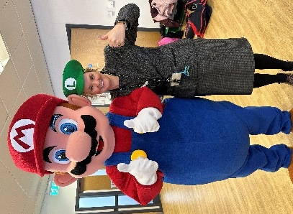

Key Dates
- School will reopen on Monday 15th April.
- School will be closed on Thursday 2nd May and Monday 6th May.
- KS2 SATS tests take place week beginning 13th May.
- School closes for half term after school on Friday 24th May and reopens on Monday 3rd June.
- School will be closed for two days for Eid in June. We will announce these dates closer to the time, but it is likely to be either 17th and 18th June OR 18th and 19th June.
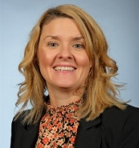
Thank you for your support,
Mrs Bell, Headteacher
