Year 4 Homework – Starling and Kingfisher
Date homework set: Thursday 18th April 2024
To be returned to school by: Tuesday 23rd April 2024

Talking Topic (10 min)
Talk to a friend or family member about our author visit with Shabana Hussain. What did she talk about and what books has she written? Have you read any of her books and which one was your favourite?

Tick when you have completed this task.

Maths (10 min)
This year, Year 4 children will be taking part in the Multiplcation Maths Check. Therefore, we would like them to practice their times tables as much as possible so that they are confident when the check comes around.
Please use the link below to practice as it is a similar format to the one used during the formal check.
https://urbrainy.com/mtc
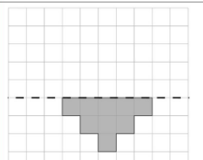
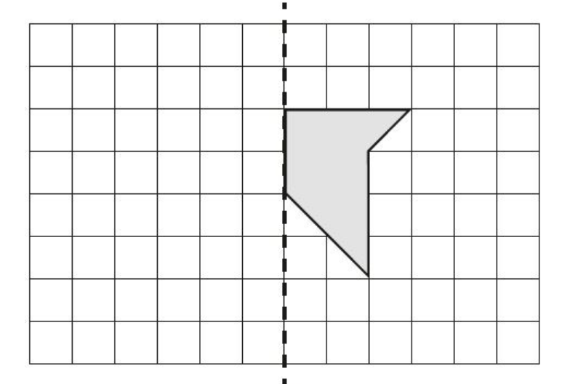
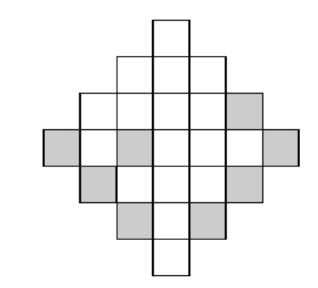
We have been looking at symmetry this week. Can you accurately reflect the mirror images below?

Tick when you have completed this task.
English (10 min)
Write down 10 things you have learned so far in chapters 1 and 2 of Gulliver’s Travels. You can use bullet points for this task. Think about the characters we have been introduced to, how they are feeling at different parts and what has happened so far.

Tick when you have completed this task.

Other tasks that could be completed;
. Practice Year 3/4 spellings.
. Times Tables Rockstar’s
. Purple Mash
. My Maths
. Read your reading book or Reading for Pleasure book.
. Complete the reading for pleasure book marks.
. Spag.com
. Bug Club
ATTENTION!
Parents and carers, please come and join us on Wednesday 24th April at 9.00am for a 15/20-minute meeting regarding the Year 4 Multiplication Maths Check.
We hope to see you there if you can make it!

