Vocabulary Dozen |  | Rock and Roll
Celts | The name 'Celts' (pronounced 'kelts') is used to describe all of the people who lived in Britain and northwest Europe during the Iron Age – from 600 BC to 43 AD |  | 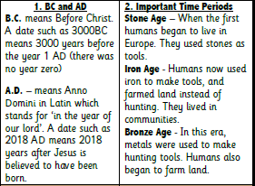  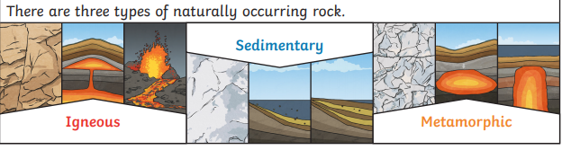 | 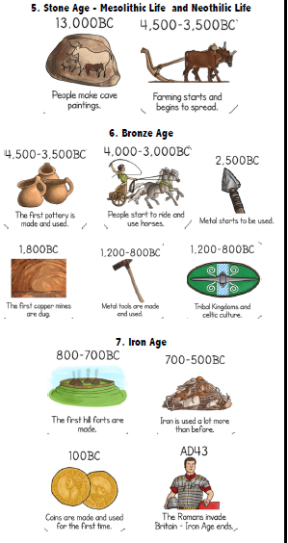
Palaeolithic, | The Palaeolithic is the old stone age.
Mesolithic, | The Mesolithic is the middle part of the Stone Age.
Neolithic. | The Neolithic is the youngest part of the Stone Age
Stonehenge | Stonehenge is a circular group of huge stone blocks in southern England.
Volcano | A volcano is a landform (usually a mountain) where molten rock erupts through the surface of the planet.
tectonic plates | Large, moving pieces called plates.
dormant | A dormant volcano is an active volcano that is not erupting, but supposed to erupt again.
active | An active volcano is a volcano that has had at least one eruption during the past 10,000 years
sedimentary | Rock that has been formed by layers of sediment being pressed down hard and sticking together. You can see the layers of sediment in the rock.
permeable | Allows liquids to pass through it.
non-permeable | Does not allow liquids to pass through it.

