Vocabulary Art |  |  | Ancient Greeks
Key Vocabulary | Word meaning |  | Timeline | 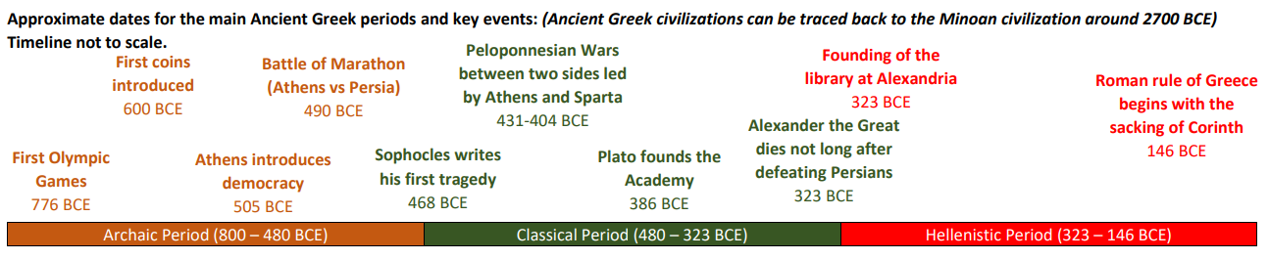
Sculpture | To form an image or representation of from solid material (such as wood or stone) |  | Where is Greece? | 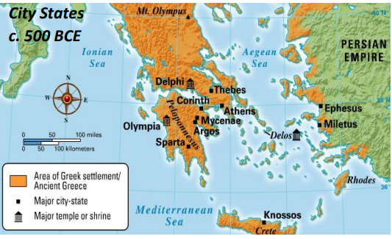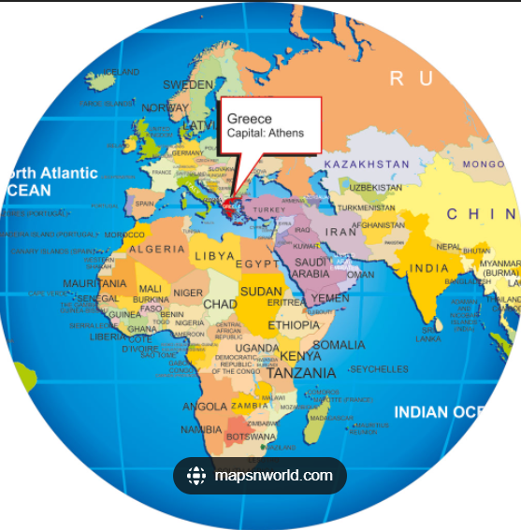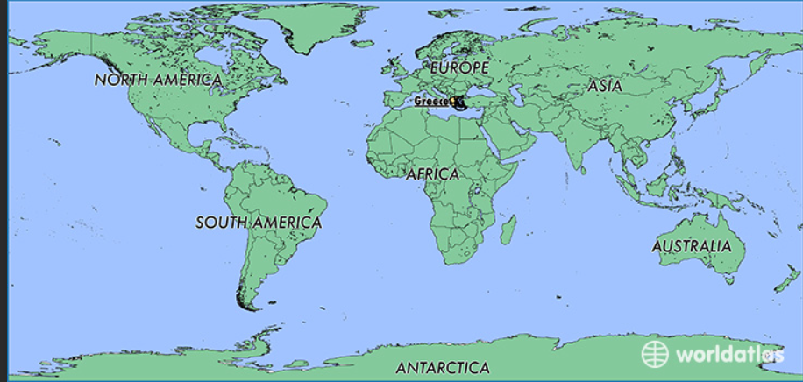
static | Not active or moving; stationary |  | Ancient Greek vocabulary  Artist- Alberto Giacometti sculptures  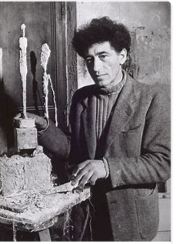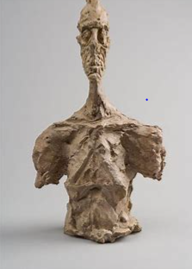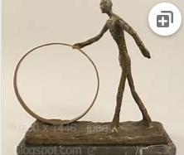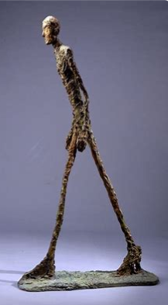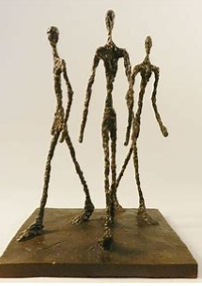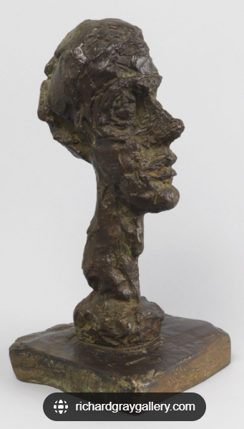 | Ancient A person who lives in ancient times.  Hippocrates The Hippocratic oath is based on the ideals of Hippocrates, a Greek physician.  Sparta Sparta was a prominent city-state in Laconia, in ancient Greece.  Athens Athens is the capital and largest city of Greece. Athens dominates the Attica region and is one of the world's oldest cities, with its recorded history spanning over 3,400 years  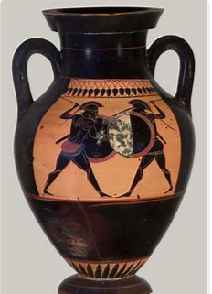
poses | To assume a particular position, as for a portrait: posture, sit.
torso | The trunk of the human body
sculpt | To cut, carve or engrave

