How to log on to Maths Whizz

1. | www.whizz.com  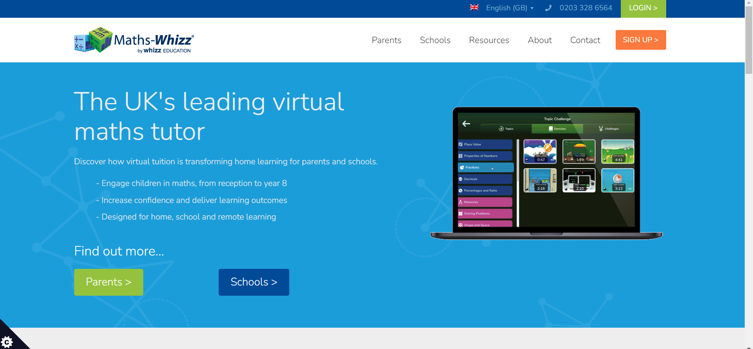
2. | Click the green ‘login’ button in the top right corner.
3. | Type in username and password.  Remember – if you have a parental account, you will have your own username and password to access your child’s progress.  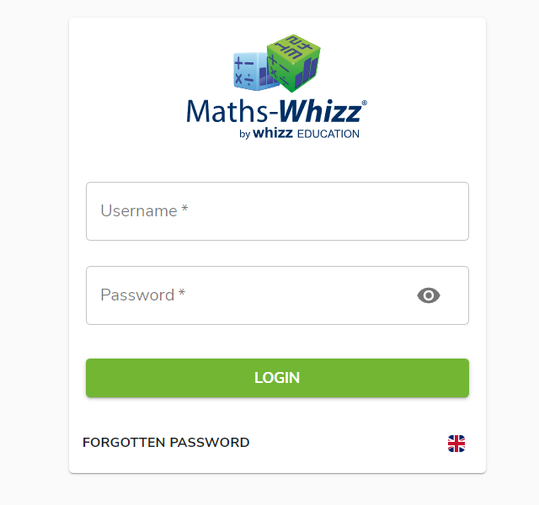
4. | The screen will show a path and a play button. This is the next lesson for your child.

Things to remember:
- Aim for 3 progressions a week.
- Around 60 minutes of learning time a week on average.
- The programme is designed to support your child, so do not tell them the correct answer. If you wish to support your child with a lesson they are stuck on, use the parental account to show the lesson and talk through it together without affecting your child’s assessment and programme.

