Write a thought bubble for a brave character.

Draw a new book cover for a non-fiction book.

Draw a new book cover for a non-fiction book.

Draw a new book cover for a non-fiction book.

Learn a fact about **Golden Eagles** and share it with your class.

Learn a fact about **Golden Eagles** and share it with your class.

Learn a fact about **Golden Eagles** and share it with your class.

Write and draw a character profile.

Write and draw a character profile.

Draw an outfit for a favourite character.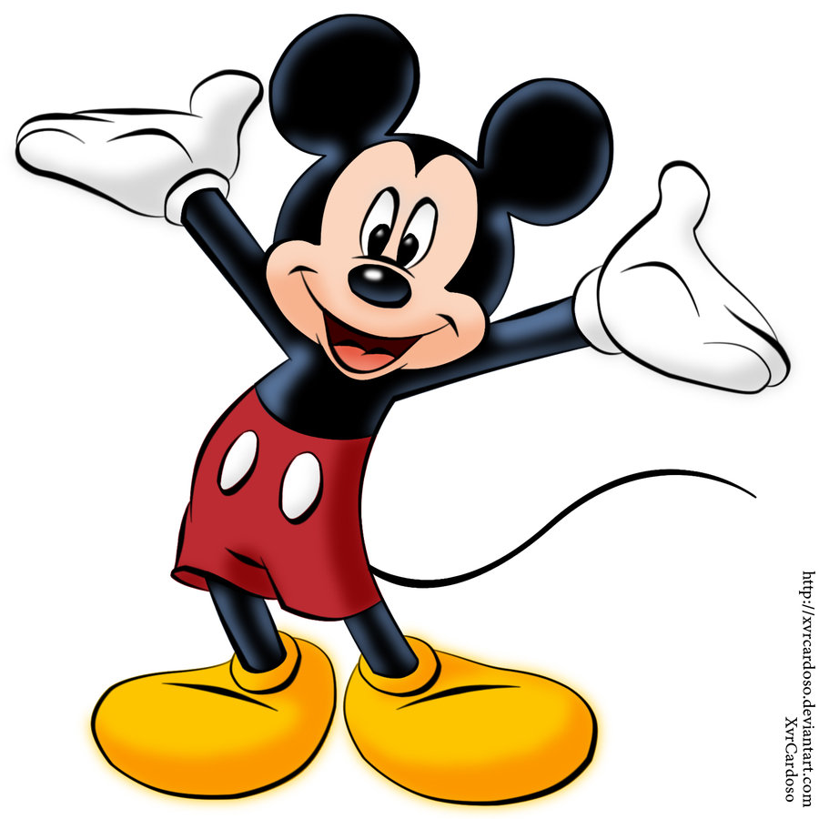

Draw an outfit for a favourite character.

Draw an outfit for a favourite character.

**Golden Eagle** Lower

**Golden Eagle** Lower

**Golden Eagle** Lower

Write a thought bubble for a brave character.

Write a thought bubble for a brave character.

Write and draw a character profile.

Create your own animal character. Draw a picture and label it to show what they are like.

Create your own animal character. Draw a picture and label it to show what they are like.

Create your own animal character. Draw a picture and label it to show what they are like.