Year 5 Homework

Date homework set: 10.11.22
To be returned to school by: 15.11.22
Talking Topic (10 minutes)
- To discuss the following topic:
“What is Remembrance Day?”
Tick when you have completed this task.
Maths (10 minutes)
Complete the following:

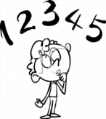
What are the factors of:
- 10
- 20
- 22
List the common factors of these three numbers.

Tick when you have completed these tasks.
Writing (10 minutes)
Write a diary entry as Mr Evans after Nick stole the biscuits.

Spellings:
Learn these spellings:
- Can’t
- Haven’t
- She’ll
- He’ll
- Wouldn’t
Include them in your writing.
Tick when you have completed this task.

