Upper Reedley - Caiman | Upper Reedley - Caiman | Upper Reedley - Caiman
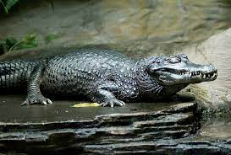  Create a poster showing researched facts about Caimans.  Read a story with a robot in it.  Draw a detailed picture of a Caiman.  Research the author CS Lewis. Say whether you would like to read his books.  Find out the meaning of an unfamiliar word.  Write a recipe for an amazing story. What would your ingredients be? | 