Upper Reedley - Giraffe | Upper Reedley - Giraffe | Upper Reedley - Giraffe
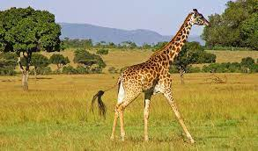  Read a detective novel.  Write a short story where the main character is giraffe.  Create a set of Top Trumps cards for giraffes.  Read a book of your choice.  Research and share facts about Giraffes.  Write a new blurb for your favourite book. | 