Year 5 Homework

Date homework set: 08.12.22
To be returned to school by: 13.12.22
Talking Topic (10 minutes)
- To discuss the following topic:
- “Who is Grandad Wheels?”
Tick when you have completed this task.
Maths (10 minutes)
Complete the following:

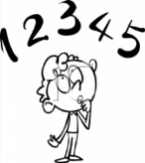
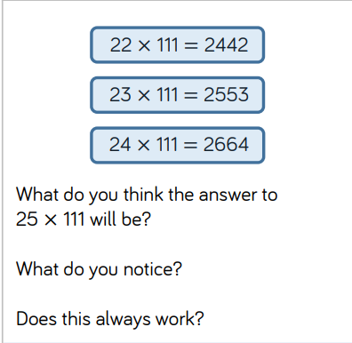

Tick when you have completed these tasks.
Writing (10 minutes)
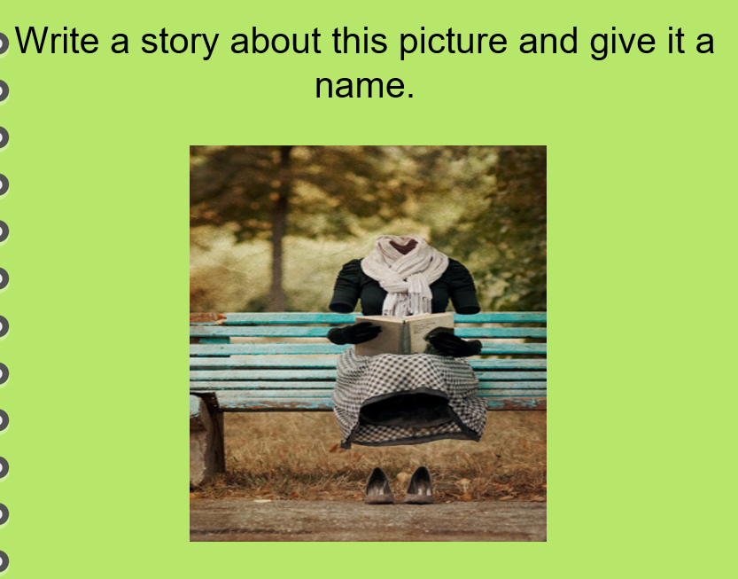

Spellings:
Learn these spellings and include them in your writing:
- Immediate
- Physical
- Language
- Familiar
- Yacht
Tick when you have completed this task.

