Friday, 06 September 2024
Dear Parents/Carers,

It has been so lovely to see the children again this week after the summer break.

Swimming
Year 5 and 6 children have been swimming this week and will swim next week too.

After that, Year 3 and Year 4 will be swimming on the following two weeks.
Mon 9th Sept  Y5 | Tue 10th Sept  Y6 | Wed 11th Sept  Y5 | Thu 12th Sept  Y6 | Fri 13th Sept  Y5
Mon 16th Sept  Y4 | Tue 17th Sept  Y3 | Wed 18th Sept  Y4 | Thu 19th Sept  Y3 | Fri 20th Sept  Y4
Mon 23rd Sept  Y3 | Tue 24th Sept  Y4 | Wed 25th Sept  Y3 | Thu 26th Sept  Y4 | Fri 27th Sept  Y3

They need:
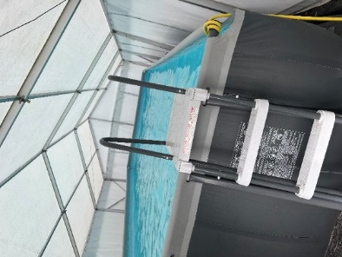
GIRLS
- A one-piece swimming costume
- A swimming hat
BOYS
- Swimming trunks or shorts.

ALL CHILDREN
- Towel
- Dressing gown
- Flip flops/crocs

The children all have individual changing cubicles and will have a shower before and after going in the pool.

Road Safety Incident
There was a near miss on the road outside school on Thursday. Two children were walking along the pavement and were almost hit by a car reversing onto the pavement. Cars should not be parking on the pavement.

Please remind all drivers to take extra care around school. We are aware that parking is very limited so I urge you to allow extra time for your journey and to park a few streets away and walk the last part.
Vehicles are not permitted to park on the yellow lines between 8am - 9am or 3pm - 4pm.
(The only exception is where cars display a blue disabled badge for a person who is in the car but these drivers can also access the staff carpark with permission as parking on the yellow lines increases the risk for pedestrians crossing the road).

Drivers are not permitted to stop on the zig zags to drop off or pick up passengers.
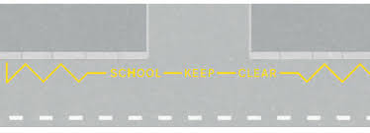

Attendance
I am disappointed with the poor attendance this week which was 90.2%.

We cannot educate your children if they are not in school.
However, the Red Fox Y4P class achieved 99.29% attendance, which is fantastic.

Punctuality
3 hours and 42 minutes of learning has been lost by children coming late to school this week. Children need to be in school by 8.50am.

Class Information
Each class has a page on our school website. This will give you key information about your child’s class and general expectations for school.

https://www.reedley.lancs.sch.uk/classes

Breakfast Club
Families must book and pay online for each breakfast club session. This starts from 7.30am every day.
You can book online using this link.
Children attending breakfast club need to be dropped off at the school door by an adult.
https://blooming-buds-childcare.pembee.app/listing/reedley-wraparound



Clubs
Care Club are running two clubs starting next week. Places can be booked online by using the above QR code. The course costs £35 for 6 weeks.

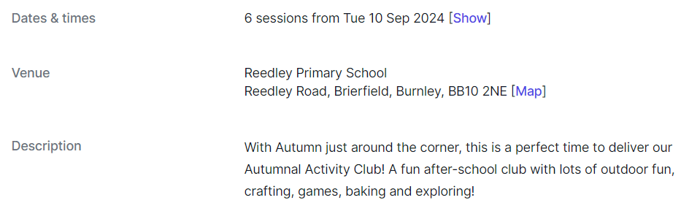
Autumn Club

Week 1 Outdoor Minibeast Hunt
Week 2 Stickmen
Week 3 Leaf Printing
Week 4 Bird Feeders
Week 5 Spooky Night
Week 6 Pumpkin Carving and Treat Night
Reedley Runners Club
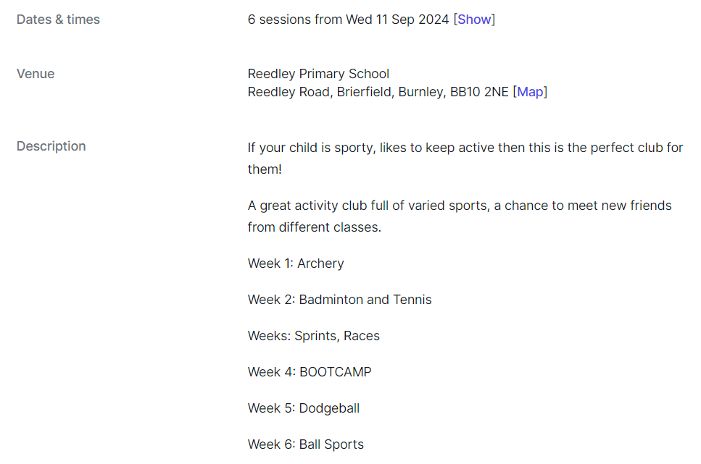

Asda Rewards

Asda are currently running a promotion where shoppers can donate money to a school.
Between 2nd September and 30th November 2024, every time customers shop with Asda using their Rewards app, the supermarket will donate 0.5% of the value of their shop to their chosen primary school.
You can find more information if you search for Asda Cash pot for Schools.
School will get £1 for every customer that signs up and selects Reedley School.
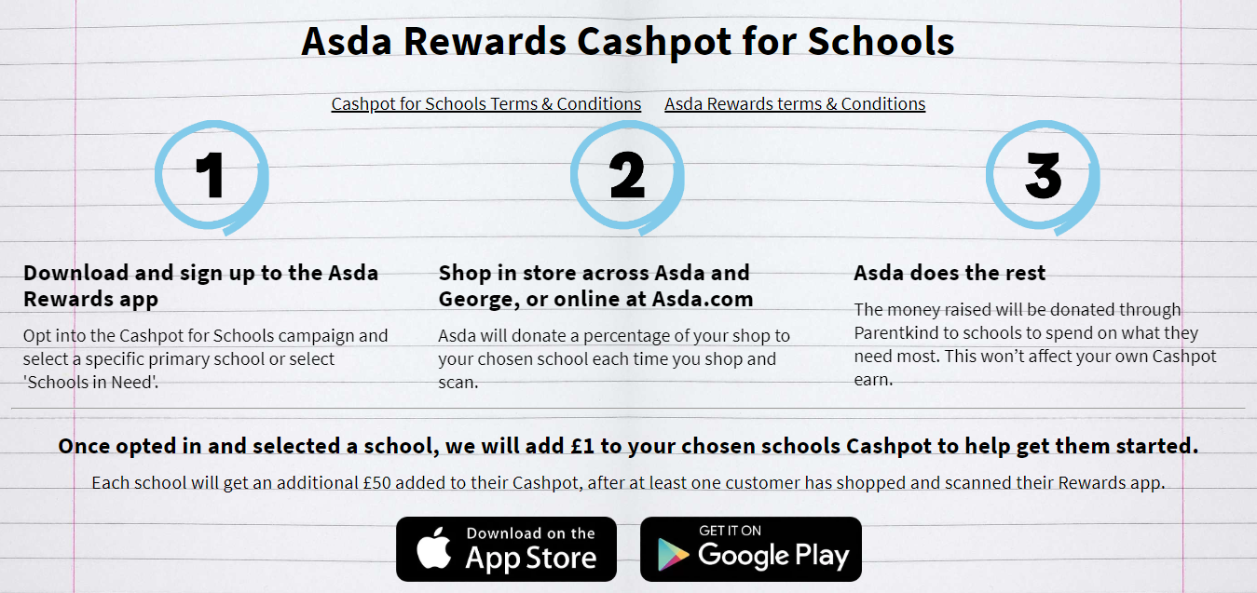

Key Dates
- Friday 4th October – families invited into school for MacMillan Coffee morning at designated times.
- School will be closed from Monday 21st October to Friday 25th October for half term.


Mrs Sarah Bell
Headteacher

