Monday, 07 October 2024
Dear Parents/Carers,
Parent Governor Election
I made an admin error with the forms for the parental election.
Please dispose of the current paperwork (ideally recycle in your paper recycling).

New forms and envelopes will now be issued after half term.

Apologies for any inconvenience.

Wear Yellow Day – Thursday 10th October
To help promote personal wellbeing for our children, we are asking the children to wear yellow clothes to school on Thursday.
Please bring £1 which will go towards providing fun activities for the children in school.
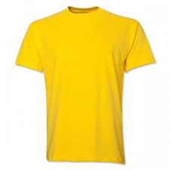
They can wear other bright colours instead if they don’t have yellow.

On Thursday all children will be learning about fun and exciting things they can do
to support their wellbeing.

Please ask your child about this when they come home and discuss whether you can take part in any activities as a family.

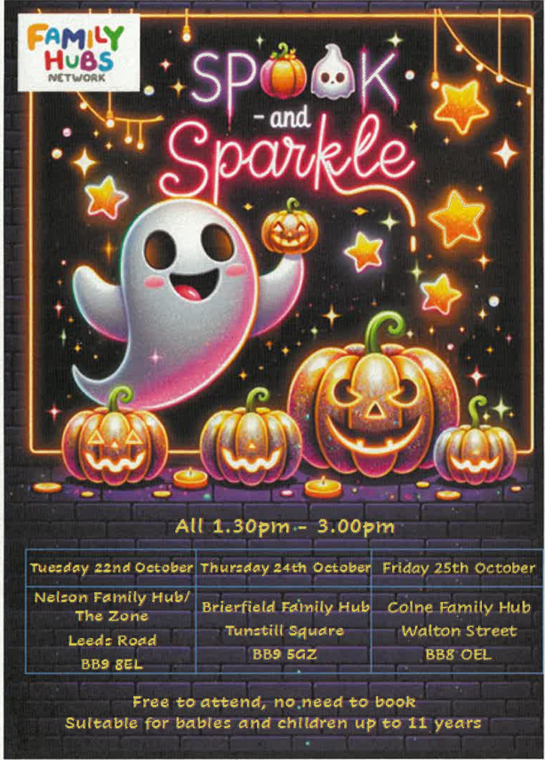

Mrs Sarah Bell
Headteacher

