Friday, 08 November 2024
Dear Parents/Carers,
Attendance
Only the Swan Class Y2S and the Mink Class Y3V met the target of 96% attendance this week
Swan 96.83% and Mink 96.55%
Overall our school attendance was 92.97% this week, which is a lot lower than last week.

Punctuality
All classes had some children arriving late this week! Oh no!

Overall, there were 10 hours and 31 minutes of lates.
Lessons start promptly at 8.50am.

Art week
Thank you to everyone who attended art sessions over the last two weeks. I know many people work and are not always able to come, but we appreciate it when you are able to do so.

See some pictures from the Reception pumpkin decorating session yesterday!
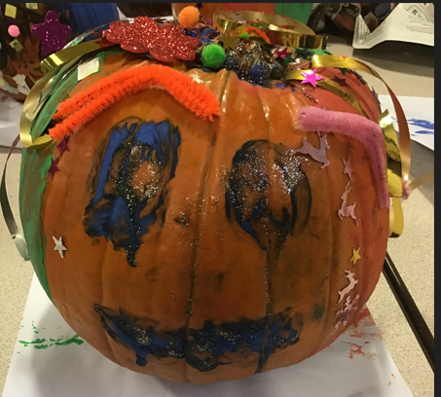
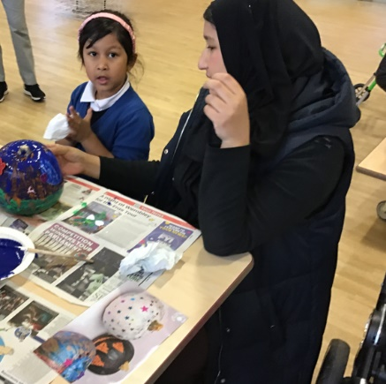
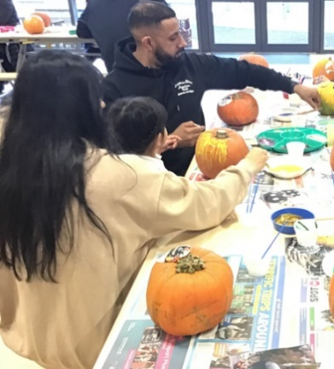

Events That Took Place This Week:
- Y1 had a trip to the church

- Sanderson’s Dance School worked with Y2

- BFC delivered an assembly to children in Y3 – 6 about racism

- Y5/6 took part in an online author visit with award-winning author Hannah Moffat. Her books can be purchased using this link https://hannahmoffatt.com/all-the-order-links-2/

Events Coming Up
- Family Learning Workshop on Tuesday 12th November on Lego robotics. This course is now full. If you have signed up, please ensure that you attend. You will need to complete a registration form prior to attending. Please note that pre-school children and babies cannot attend this event.

- Y4 will be going to the cinema on Thursday. If you have not brought your £5, please can you bring it before Thursday.


- Friday 15th November – children can come in yellow or non-uniform and bring £1 for BBC Children In Need

ICT session
On Tuesday 26th November at 9:30am, Y5 and Y6 are watching an online assembly related to Online Safety. We are inviting any parents of Y5 and Y6 children to come into school to watch the assembly in the hall at the same time as the children.
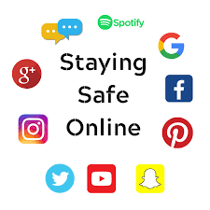
If you would like to attend this session, please call or send a message to Mrs Iqbal, so we can have enough chairs set out in the hall for you.

BBC 500 words
Thank you and well done to the children who submitted an entry for the BBC 500 Words competition. From the entries, we have selected one per class to forward onto the competition and the children have been given certificates today if their work was chosen.

If your child’s entry has not been selected, you can submit it online yourself. The closing date for this is 9pm today! (Friday 8th November)

https://www.bbc.co.uk/teach/500-words/articles/zqc8mbk

Christmas Fair
We will be having our Christmas Fair on Thursday 12th December to raise vital funds for the school. We will be asking for chocolate donations nearer the time, but we are also hoping to get good quality donations for raffle prizes.
If anyone is able to donate anything or works for a company who would be able to do so, please let me know. We would be looking for anything suitable that our families would like to win. This could be vouchers, gifts or other quality items.

Glass Bottles
A number of children have been bringing glass bottles to school for their water or for their packed lunches, which includes if they go on a trip. This is not allowed for safety reasons. Water bottles should be plastic, transparent and contain only water.

Parent Governor Election
Ballot papers need to be returned to school, no later than 11am on 12th November.

Tuck Shop
Thank you for all your contributions for the cake sale last week and to everyone who bought any items. We raised £251 for school.

We will be selling small food items on a Friday after school every week now, to raise money for various items in school, including our potentially life-saving anaphylaxis kit.

We will be selling cakes, biscuits and drinks for 50p to £1. This will start on Friday 15th November.


If it is raining, the tuck shop will take place in the hall.

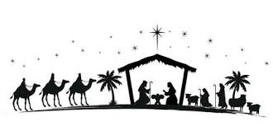
Nativity
Our Reception, Year 1 and Year 2 children will be taking part in our annual nativity show on
-Monday 9th December from 2.15pm
And
-Tuesday 10th December from 2.15pm

The Reception and Year 1 children are performing the nativity and Year 2 will be supporting with singing and each Y2 class will perform a song.

There is an allocation of 2 tickets for each child, which will cost £1 per ticket
Families can buy both tickets for one of the performances or you can choose to have one ticket for each of the two performances.
Tickets will be available to buy from your class teacher from Monday 18th November – Friday 29th November.
Tickets are limited to two per child due to fire regulations in the hall. However, if all the tickets have not been purchased by Monday 2nd December, then the spare tickets will become available for families to purchase an additional ticket if they wish to.

Labelling Property
Please label ALL items of children’s clothing and property. Every day there are jumpers and coats handed to me that have no names, so I can’t return them to their owner.
Please also label bags, hats, gloves and anything else that your child brings to school!

Establishing Routines
There is a really good course running in school for parents on Thursday 21st November from 1.45pm to 3.15pm. The focus is on developing good routines, to take away some of the stresses that we all feel when trying to get anything done in the home!
It is free to attend and will be supportive and non-judgemental. There is a leaflet below. If you want to book on, please call the school office.

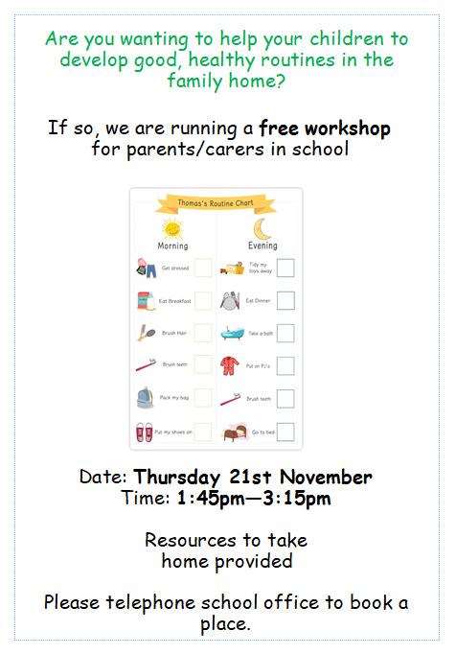


Mrs Sarah Bell
Headteacher

Key Dates

- 14th November – Y4 children going to the cinema.

- 18th November – Tickets go on sale for the Nativity performance.

- BBC Children In Need appeal – wear non uniform and bring £1 on Friday 15th November.

- Tuesday 26th November - Parents of Y5/6 invited to assembly on online safety

- Friday 29th November – We are asking for donations of chocolate for the tombola for the Christmas Fair

- Monday 9th December and Tuesday 10th December 2.15pm YR, Y1, Y2 nativity – entry with tickets only

- Thursday 12th December – Christmas Fair 3.45 – 4.45pm

- Friday 13th December – Children’s Christmas dinner

- Friday 20th December – Christmas themed non-uniform day. Bring £2 for school.

- School will be closed from Monday 23rd December for the Christmas holiday, and reopen on Tuesday 7th January.

