Tuesday, 03 December 2024
Dear Parents/Carers,

Attendance
Red Fox Y4P (97%) met the target of 96% attendance this week.
Overall our school attendance was 93% this week.

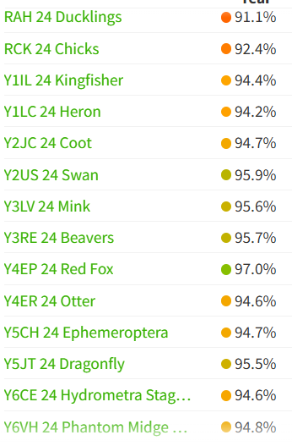

Medicine
We can administer medicines to children in school. Parents/carers need to come to the school office to give us the medicine and complete a form, noting the name of the medicine and the dosage.
Medicine must not be sent in directly with the children or in their bags.

We are also able to give Calpol in school if children have minor illnesses. However, we ask that you send Calpol into school for this purpose when needed, labelled with your child’s name.


Reporting Absences
If you child is not well enough to attend school, please use Studybugs to report the absence. You can download the Studybugs App on your phone. This enters the mark directly into the school register and the system can send you NHS advice on your child’s condition. You may get a call back from school, especially if they are absent for more than one day, to check how they are.



You might also receive messages from Studybugs directly to your phone. This will inform you of current attendance levels, inform you if your child’s attendance has dipped or congratulate your child’s good or improving attendance.

Punctuality
Please remember that children need to be in school by 8.50am. If they arrive late, you will receive a text informing you of the late mark.

If your child arrives after 9.20am, they receive a U mark, which is recorded as a session of unauthorised absence.

Remember that 10 sessions of unauthorised absence could result in parents receiving a fine.

Recent Events

- Tuesday 26th November – Y5 & Y6 children took part in the assembly related to Online Safety.

- 27th November – Lancashire Day – the children discussed
our county of Lancashire.

- Tuesday 26th November – Y2 took part in a virtual author visit with Claire Freedman.

- Friday 29th November - Y5T took part in a virtual visit with author Emmanuel Asuquo.

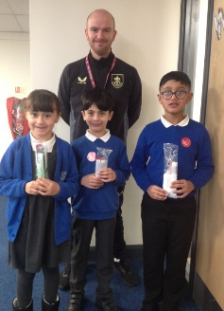
- Year 3 had another session this week about healthy food and drink choices and received a free toothbrush pack from Burnley Football Club.

TRIKIDZ
On Thursday 28th & Friday 29th November Y4, 5 and 6 took part in a duathlon/triathlon event in school. The combined running and cycling (on static bikes) helped children to get an insight into what it like to do a multi-sport event. Children who took part on Friday used resistance bands to imagine they were also swimming.
It was high intensity and the children really enjoyed it. Mrs Hornby and I also enjoyed competing in the cycling activity, although Awais was far faster than me!
I have invited the coaches to return later in the school year when Y4, 5, 6 children can have another turn and children from other classes will be able to have a go too!
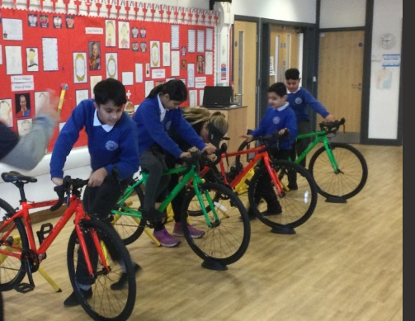
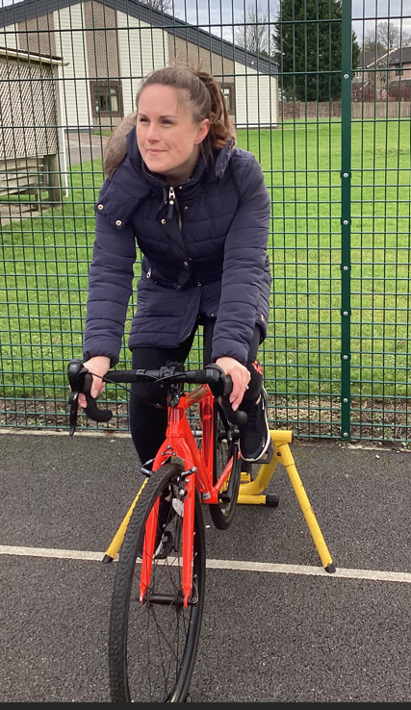

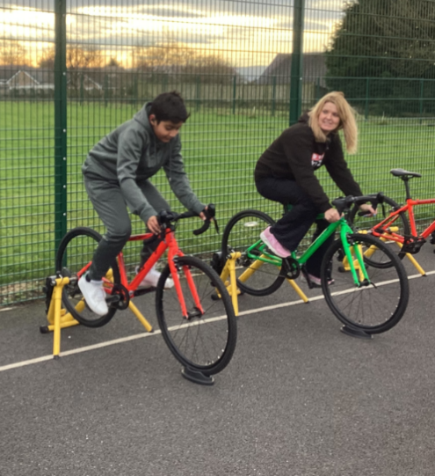

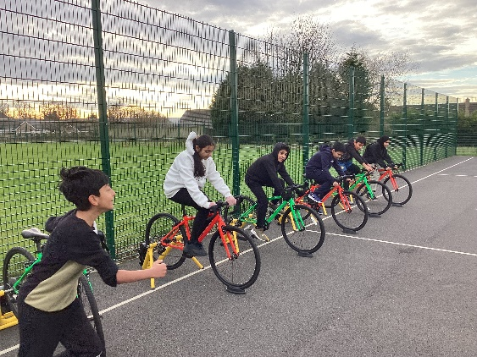

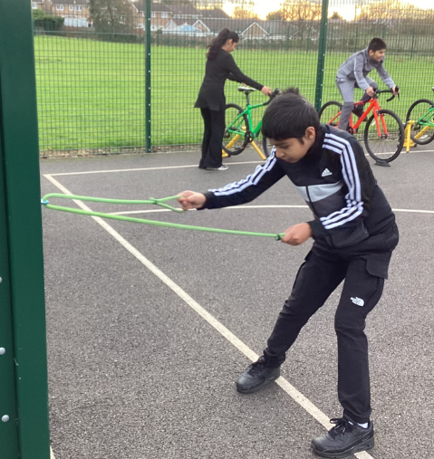
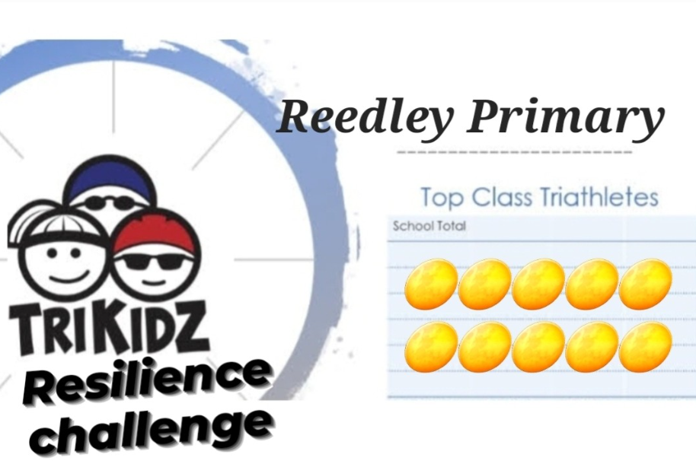

Christmas Fair
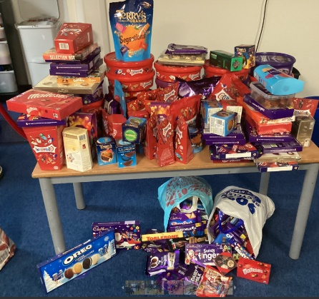
- Thank you for your very generous donations for the Christmas Fair. We really appreciate your generosity.

At the fair, there will be an opportunity for children to spend time in an Elf Workshop.
If you want your child to take part in this event, you must buy a ticket in advance. Tickets cost £3.00 and go on sale on Thursday 5th December in the hall from 3.35pm. There are limited tickets available and will be sold on a first-come first-served basis.


Raffle tickets will be on sale after school starting from Monday 2nd December.
Tickets are £2 for 5 tickets.
Prizes include:
- 2x £10 beauty vouchers from Tropic Skincare range.
- 2x £10 B & Q vouchers
- Voucher for 2 people to have 2 hours in the Leisure Club at the Oaks followed by Afternoon Tea
- Ticket for 2 people to see a home match as Burnley Football Club (currently 3rd position in Championship)
- Sweet/chocolate hamper
- Child’s stationery voucher
- Adult beauty product voucher
Thank you to other parents who have also donated a range of other items
over the last couple of days.

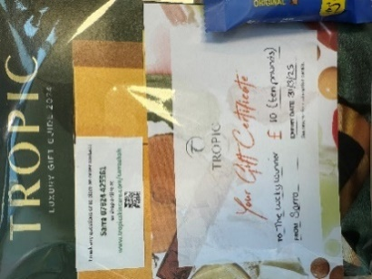
More prizes are coming in all the time – more to follow next week!


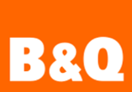
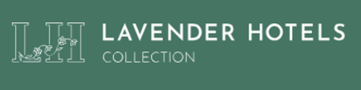

Nativity
Our Reception, Year 1 and Year 2 children will be taking part in our annual nativity show on

-Monday 9th December from 2.15pm
and
-Tuesday 10th December from 2.15pm

Design and Technology Work

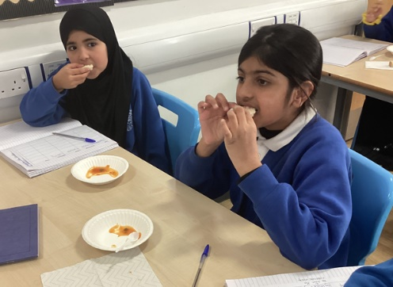
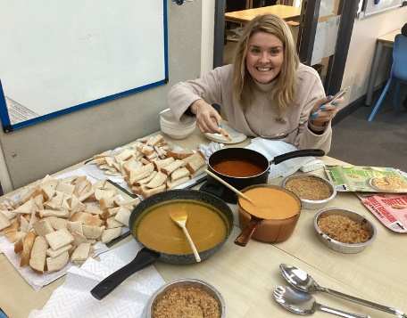
I was very lucky to be invited into Y5 classrooms this week. They are doing a design unit all about food and were tasting different food before designing their own. We tasted three types of soup, two types of bread and two crumbles. Not a bad way to spend a morning. I will be returning next week to see their creations!
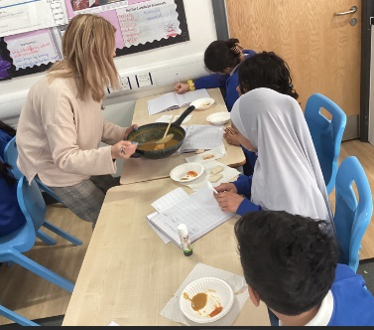

Children Starting School in September 2025

If you (or anyone you know) have a child born between 01.09.2020 and 31.08.2021 then you need to apply for a school place no later than 15th January 2025.
You can this link to apply.
https://www.lancashire.gov.uk/children-education-families/schools/apply-for-a-school-place/starting-primary-school/

We are having an open session for prospective parents to have a look at the setting on Thursday 5th December from 2.30pm to 3.00pm. Please spread the word if you know people who are looking at schools for next September

Curry on The go
Year 5 and Year 6 children have decided to collect items for the Curry On The Go charity -see the leaflet below.

Thank you all for your support,

Mrs Sarah Bell
Headteacher

Key Dates

- Thursday 5th December 14.30 – 15.00 Open session for families who have a child to start in Reception Class for Sept 2025

- Monday 9th December and Tuesday 10th December 2.15pm YR, Y1, Y2 nativity – entry with tickets only

- Thursday 12th December – Christmas Fair 3.45 – 4.45pm

- Friday 13th December – Children’s Christmas dinner

- Friday 20th December – Christmas themed non-uniform day. Please bring £2 for school.

- School will be closed from Monday 23rd December for the Christmas holiday, and reopen on Tuesday 7th January.





