Friday, 17 January 2025
Dear Parents/Carers,

Attendance

Whole school attendance this week is 95.46%. This is very close to our target of 96%. It would be great to keep this up. Well done to Y5T who achieved 100% attendance this week.

School closure last week - The children did not incur any absences whilst the school was closed. Unfortunately our automated system may have sent messages to you, stating that your child’s absence has dropped. This was sent before we were able to enter the school closure onto the system. Please disregard any messages about attendance that you received last week.

Year 2S Swan Class had their non-uniform today as they had the best attendance last half term. They will get another non-uniform day next Friday as they also had the best punctuality.

These five class had the highest attendance this week.
Dragonfly Y5T | 100%
Hydrometra Stagnorum Y6E | 99.26%
Ducklings Rec H | 99.16%
Red Fox Y4P | 98.65%
Ephemeroptera Y5 | 98.52%

Punctuality
Year 2S Swan Class had the best attendance this week. There was only one late throughout the week in this class.

Please remember that school starts promptly at 8.50am.


School Spider App
Please can all families ensure that they have downloaded the School Spider App.
This is the main way that we send messages. We also use this for you to book parent evening meetings.

Clubs
Clubs started again this week. Please ensure that children are collected promptly after the clubs. It is lovely to see the children enjoying the different things on offer.

Events This Week
Sanderson’s Dance supported Year 4 and Year 1 with their dance lessons this week. The children told me that they really enjoyed the dance sessions. Some of the Y4 children were even teaching me the new dance moves at lunchtime!
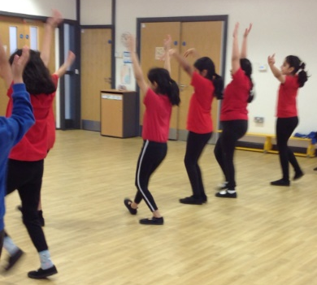

Year 3 have been doing some exciting work as part of their topic on the Stoneage. They were all doing cave drawings. They all pretended that they were in caves by turning the tables over!
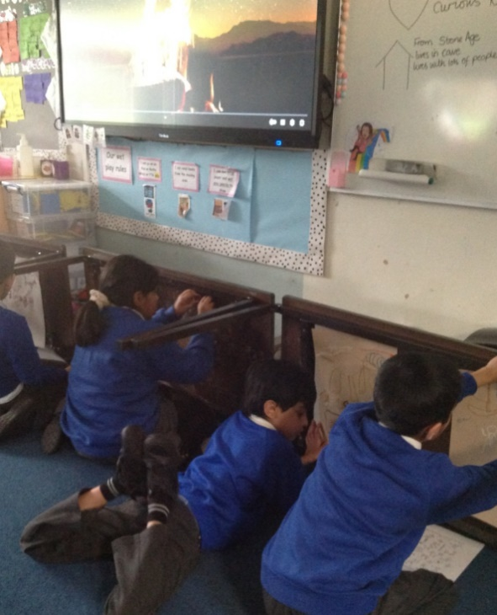

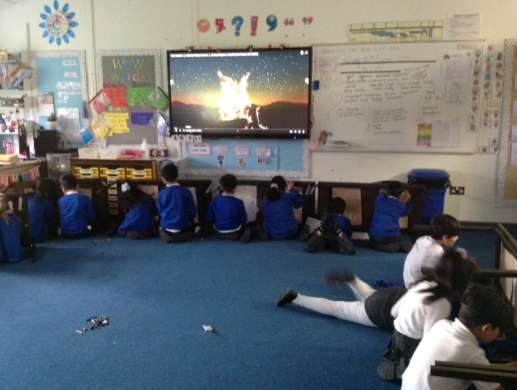

Upcoming Events
Y6 will be having a school trip to the museum next week
- Y6H will be going on Wednesday
- Y6E will be going on Thursday
If you have not paid for the trip, please send the money into school as soon as possible.

Times Table Rockstars – Competition on Friday 7th February

As part of our commitment to make maths exciting and high profile in our school, we are taking part in a friendly competition involving schools across the UK. The competition runs from 07:30 GMT Friday 7th February 2025 to 19:30 GMT Friday 7th February 2025. It's all done online via play.ttrockstars.com.
Children can play in any game mode with every correct answer to a multiplication or division question, earning themselves, their class and the school a point. The Times Tables Rock Stars platform will calculate the class average (the number of correct answers per pupil in the class who play during the competition hours, subject to a daily 60-minute limit (see below). Winning classes in the school and in the competition as a whole will be the ones with the highest average.
To support player wellbeing, there is a daily time limit of 60-minutes per player. In other words, each player can earn competition points for up to 60-minutes between 07:30 GMT and 19:30 GMT on 07:30 GMT Friday 7th February 2025 to 19:30 GMT Friday 7th February 2025. Once the player goes beyond 60-minutes of play on that day, they will still earn coins but will no longer earn points towards the competition.
In the spirit of the competition, please don't play on their behalf but by all means encourage and support them to the extent that it doesn't cause high stress levels or impact on family plans.

Thank you for your support,


Mrs Sarah Bell
Headteacher

