Friday, 31 January 2025
Dear Parents/Carers,

Attendance

Whole school attendance this week is 96.37%. We have achieved our target! Please keep this up!
These five class had the highest attendance this week. Nine classes in total met the target of 96%+

Beavers Y3E | 99.28%
Hydrometra Stagnorum Y6E | 98.15%
Dragonfly Y5T | 97.80%
Heron Y1C | 97.78%
Otter Y4R | 97.57%


Punctuality
Year 2C Coot Class had the lowest number of lates this week.
Please remember that school starts promptly at 8.50am.

Upcoming Events
- Rec, Y1, Y2 and Y4 classes will be having a taster session of cricket on Monday 3rd February.

(Y3 and Y5 will have cricket sessions later in the school year)

- Year 1 families are invited into school for a ‘Come Read With Me’ session at 9am on Monday 3rd February. They will work alongside their child to create resources to carry out fun reading activities at home.

- All children will take part in a ‘numberfun’ session on Tuesday 4th February.

- Friday 7th February – children to wear their school uniform inside out as part of our mental health awareness day.

- Friday 7th February – children to take part in the Times Table Rockstar online competition with other UK schools.

On-Line Programmes
We are going to run a session in school for parents/carers to attend, so that you can become more familiar with the on-line programmes that we use. This will include Maths Whizz, Numbots, TT Rockstars and Purple Mash. We will show you how to log on and how to navigate your way around the software. Your child will join you for the session and you can explore the programmes together.

The session will be on Thursday 13th February from 2.30pm.
Please register for the session if you would like to attend.
You can send Mrs Iqbal a message on Whatsapp on 07973 543932 or you can send a note in on a piece of paper.
Please state your child’s name and year group/class clearly on the message.






Homework
A parent recently mentioned that they feel the weekly homework is too much for the children. The Leadership Team met this week to review the homework in light of this.
We feel it is important for children to share their learning with family at home and for them to consolidate skills covered in school.
However, we feel that there should be a balance between family life and school work.

We have decided to keep some elements of the homework, to stop giving some of the tasks and to make others optional for those children who have the time to do more.

What we will continue to ask children from Year 1 – Year 6 to do each week:
- At least 3 sessions of 10 minutes reading from a school reading book
- 30 minutes of Maths Work on Maths Whizz or Numbots. These programmes set work at your child’s level which is better than a Maths task planned for the whole class.

Thursday homework tasks:
- 5 – 10 minutes practising some spellings
- 5 - 10 minutes learning time table facts
- 5 minutes doing ‘talking homework’, where children discuss an aspect of their learning with someone at home
- Reading for Pleasure Awards

What we will stop asking children to do for homework:
- Pieces of writing
- Additional Maths tasks

Optional Tasks that your child can do:
- Spag.com
- Reading the school library book

Some children have other programmes such as Nessy or handwriting practice. These should take priority over other aspects of homework.

Reception Classes Homework
Children in Reception should practise reading at least three times a week and should play the phonics games that are sent home. Please ask your children to tell you about the learning that they do, which will also reinforce the learning that they have done.

You can also support your child by using basic Maths around the house such as counting objects and adding small number of objects together.

Traffic
I am increasingly concerned about the traffic around our school at drop-off and pick up times.
We witness a number of things regularly that concern us such as children getting out of cars in the middle of the road into oncoming traffic and young children in cars without car seats. We also see cars stopping on double yellow or single yellow lines, which restrict the view of people crossing the road.

There are a number of drivers who have a blue disability badge which helps them park closer to the school for the benefit of the child or adult entitled to the blue badge.
However, drivers with a badge should not cause an obstruction or danger to other road users.

I have requested a crossing patrol (lollypop man or lady) on numerous occasions over the last 10 years but Lancashire County Council have told me each time that we are not eligible for one.

I urge all drivers to think carefully about how they drop children off and pick them up. One poor decision could result in tragedy. Please take time to drop your children off in safe places and escort them to school, holding hands with them whilst you cross roads. We need them all to be safe.





Events This Week
- Children from Y1 – Y6 were able to find out about a range of musical instruments today when Rocksteady visited the school. Some children performed some pop/rock music as a band. Leaflets have been given out to the children with an opportunity to take part in a regular session where they learn to play instruments as part of a band such as keyboard, drums guitar or bass. There is a cost of £42.79 per month. If there are enough children whose families wish them to sign up for this, then this will run in our school.
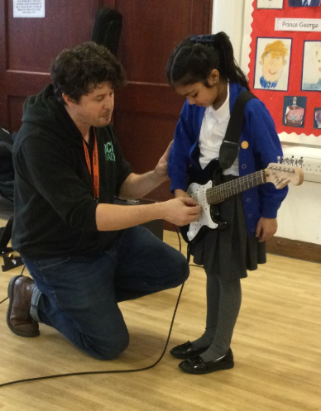
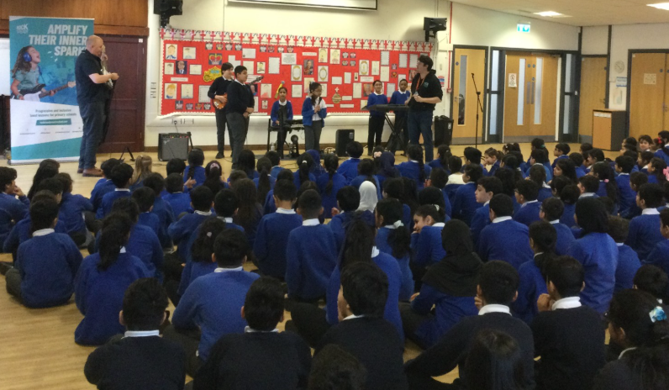

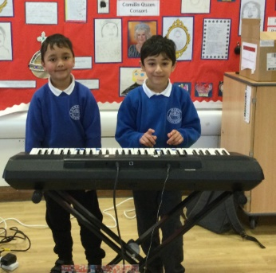
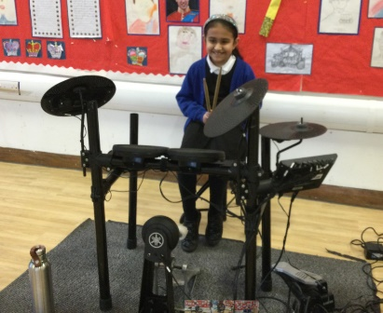

Pictures from today’s
Rocksteady assemblies!

Key Dates

Mental Health Awareness Day - children to wear uniforms inside out on Friday 7th February

Parent/child Workshop for On-Line Learning – Thursday 13th February 2.30pm. Please notify us if you are able to attend.

Half term – school will be closed from Monday 17th February to Friday 21st February and will reopen on Monday 24th February.

World Book Day – Thursday 6th March. Dress as a book character.

Eid - School will be closed on Monday 31st March and Tuesday 1st April.

Easter – School will be closed from Monday 7th April for the Easter break. It will reopen on Tuesday 22nd April.

School will be closed to pupils on Thursday 1st May as school is used as a polling station for local elections.

Thank you for your support,
Mrs Sarah Bell, Headteacher

