Friday, 11 July 2025
Dear Parents/Carers,

Summer Holiday
School will close at 1.30pm on Wednesday 23rd July. School will reopen to pupils on Tuesday 2nd September


Attendance

Whole school attendance this week is 92.23%.
Only one class met the target of 96% attendance this week

Hydrometra Stagnorum Y6 Mrs Hardman’s class | 97.41%

Reports
Annual reports have been sent out today via email. If you haven’t received it, please check all email account including junk boxes. If you still haven’t got it, please call school next week.
If anyone wants to discuss the report with their child’s classteacher, please call the school office to make an appointment.

Y6 Residential to Whitehough
33 of our Y6 children went to Whitehough this week for a three day/two night residential trip.
They took part in a range of activities such as archery, high ropes course and orienteering. However, I think the biggest challenge night have been them all putting the bedding on their beds!
Zach said ‘I loved the Leap of Faith best because you get to go really high and then you jump to touch the ball and I feel like it was a huge achievement because I managed to touch the ball. I thought I might fall really fast but the harness stopped me falling. I would definitely do it again if I could!’.
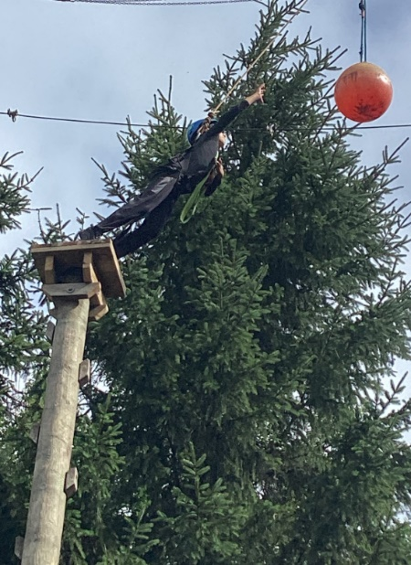

Letters have been sent out to current Year 5 children
to see if there is enough interest for a residential in June 2026.
Please return slips by Monday if you want your child to attend.
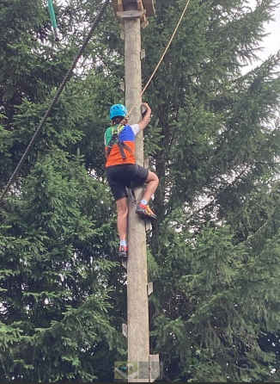
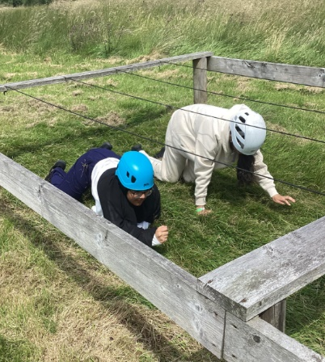

Cricket sessions
I have been asked to share the following cricket session with parents.


Sport Ambassadors
Our new sport ambassadors have been chosen for the year ahead. These are from our current Year 5 children who will be Year 6 in September. They will support children from Year 3 and Year 4 by giving running games for them during some playtimes.

From Y5T – Zaara, Furqaan, Eesa, Ayisha, Arooj, Musa, Fatima, Sami, Hanna, Hassan
From Y5E – Mysha, Hamza, Keyaan, Zayna, Douaa, Noor, Yusuf, Hamid, Rua, Hashim

Upcoming Events
SEND meetings
If your child has additional needs, you will be invited to meet their teacher to discuss their progress. In many cases you will be able to meet both the current teacher and the teacher for September.

Stay and Play
Children who are due to start in Reception in September are invited to attend Stay and Play sessions.
These are:
Monday 14th July 9.15 – 10.00am
Thursday 17th July from 2.30 – 3.15pm

Reception Class – Pirate Day


On Wednesday 16th July the children in Reception are asked to dress like a pirate. They will be a wide range of fun activities taking place throughout the day! Yargh!

Key Dates

- Attendance Treat – during the week of Monday 14th July, all of the children who have achieved 96%+ attendance for the Summer Term will take part in an attendance treat.

- Y6 Leavers’ assembly – families of our current Y6 children are invited to attend their final assembly on Wednesday 23rd July from 9.15am.

- Summer Holiday School will close at 1.30pm on Wednesday 23rd July.
School will reopen to pupils on Tuesday 2nd September


Thank you for your support, Mrs Sarah Bell, Headteacher

